

**Name of the Student:-** Prankur Agarwal

**Class:-** XII

**Subject Incharge:-** Mr. Mohit Saras

**School Name:-** Delhi Public School Ghaziabad

#### Certificate

This is to certify that PRANKUR AGARWAL of class XII of Delhi Public School Ghaziabad has worked under my supervision on the project titled “**Medical Record Management System”** and has completed it to my total satisfaction.s

**Signature**

Mr. Mohit Saras

Teacher Incharge (Informatics Practices)

Delhi Public School Ghaziabad

**Acknowledgement**

It gives us immense pleasure to express our sincere and deep feelings of gratitude to our Informatics teacher **Mr. MOHIT SARAS**, who has given us his invaluable moral support from time to time, and helped & co-operated with us in preparation of this Project.

I am also grateful to **My Parents** and **My Siblings** for their constant help and cooperation.

PRANKUR AGARWAL

Class -XII

**INDEX**

|  |  |  |
| --- | --- | --- |
| **SNO.** | **TOPIC** | **PAGE NO.** |
| 1. | System Description at a Glance | 5 |
| 2. | Problem Description | 6 |
| 3. | System Requirement | 7 |
| 4. | Database Design | 8 |
| 5. | Design View, Coding, Run View | 10 |
| 6. | Bibliography | 78 |

**System Description At a Glance**

Medical Record is the collection of information concerning a patient and his or her health care that is created and maintained by the organization. A Medical Record shall be maintained for every individual who is evaluated or treated as an inpatient, outpatient, or emergency patient of a hospital, clinic, or physician’s office.

**Problem Description**

This project can be used to establish guidelines for the contents, maintenance, and confidentiality of patient Medical Record. As it is very difficult to record all the data manually in a register and do operations in it, this project makes all these processes easy. As today the world is becoming more computerized, this project meets the demand of the medical world.

**System Requirement**

• Windows 7

• Processor: Intel i5

• Installed memory: 4 Gb

• Java Development Kit 8

• NetBeans 8.0

• MySQL 5.1

• MySQL JDBC Driver

**Database Design**

drop database mrproject;

create database mrproject;

use mrproject;

create table user(

First_Name varchar(30)not null,

Last_Name varchar(30)not null,

DOB date not null,

Username varchar(50)primary key,

Password varchar(16)not null

);

insert into user values('Admin','Agarwal','2014/07/04','admin','password');

create table patient(

pno int primary key auto_increment,

p_name varchar(35) not null,

b_gp varchar(3) not null,

age int(3),

gender varchar(6) not null,

mobileno varchar(10),

rel_name varchar(35) not null,

father_name varchar(35),

address varchar(50),

disease varchar(20),

entry_date date

);

insert into patient (p_name,b_gp,age,gender,mobileno,rel_name,father_name,address,disease,entry_date) values ("Vasu Agarwal","O+",17,"male","9877876565","abc","xyz","Shastri nagar","heart",'2013-02-05');

create table doctor(

dno int primary key auto_increment,

d_name varchar(35),

edu varchar(25),

specialization varchar(20),

charge int(3)

);

insert into doctor (d_name,edu,specialization,charge) values ("Aman Kapoor","MBBS","heart",1500);

create table prescription(

pid int primary key auto_increment,

pno int(11) references patient(pno),

dno int(11) references doctor(dno),

pric varchar(100),

visitno int(3),

pricp_date date,

days int(3) not null,

cost int(5),

reference int

);

insert into prescription (pno,dno,pric,visitno,pricp_date,days,cost,reference) values (1,1,"rest",1,'2013-02-05',5,6000,null);

create table invoice(

inno int primary key auto_increment,

pid int(11) references prescription(pid),

pno int(11) references patient(pno),

dno int(11) references doctor(dno),

bill_date date,

amount int(5),

modepay varchar(11)

)

auto_increment=1000000;

**Database Explanation**

• Table 1: Signup/Login Table

• Table 2: Patient Table

• Table 3: Doctor Table

• Table 4: Prescription Table

• Table 5: Invoice Table

**DESIGN-VIEW, CODING, RUN-VIEW**

Logo



**private void formWindowOpened(java.awt.event.WindowEvent evt) {**

this.setBackground(new Color(0,0,0,0));

try{

Thread.sleep(2500);

new Slide_Continue().setVisible(true);

this.dispose();

}

catch(Exception e){

}

**}**

Slide To Continue



**private void jSlider1MouseReleased(java.awt.event.MouseEvent evt) {**

int i = jSlider1.getValue();

if(i>75){

new Options().setVisible(true);

this.dispose();

}else{

jSlider1.setValue(0);

}

**}**

**private void formWindowOpened(java.awt.event.WindowEvent evt) {**

this.setBackground( new Color(0,0,0,0));

**}**

**private void jLabel6MouseReleased(java.awt.event.MouseEvent evt) {**

System.exit(0);

**}**

Options

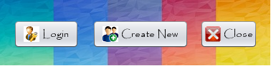

**private void jButton1ActionPerformed(java.awt.event.ActionEvent evt) {**

new Login().setVisible(true);

this.dispose();

**}**

**private void jButton2ActionPerformed(java.awt.event.ActionEvent evt) {**

new New_User().setVisible(true);

this.dispose();

**}**

**private void jButton3ActionPerformed(java.awt.event.ActionEvent evt) {**

new Slide_Continue().setVisible(true);

this.dispose();

**}**

**private void formWindowOpened(java.awt.event.WindowEvent evt) {**

this.setBackground(new Color(0,0,0,0));

for(double i = 0; i<=1.0; i = i + 0.1){

String val = i + "F";

float f = Float.valueOf(val);

this.setOpacity(f);

try{

Thread.sleep(50);

}

catch(Exception e){

}

}

**}**

Login

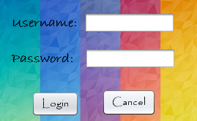

**private void jButton2ActionPerformed(java.awt.event.ActionEvent evt) {**

new Options().setVisible(true);

this.dispose();

**}**

**private void jButton1ActionPerformed(java.awt.event.ActionEvent evt) {**

if(jTextField1.getText().isEmpty()){

JOptionPane.showMessageDialog(this,"Please enter username!");

}

else if(jPasswordField1.getText().isEmpty()){

JOptionPane.showMessageDialog(this,"Please enter password!");

}

else{ String username=jTextField1.getText();

String password=jPasswordField1.getText();

try{

Class.forName("java.sql.Driver");

Connection con=(Connection)DriverManager.getConnection("jdbc:mysql://localhost:3306/mrproject","root","");

Statement stmt=(Statement)con.createStatement();

String query= "Select * from user where username='"+username+"' and password='"+password+"';";

ResultSet rs=(ResultSet)stmt.executeQuery(query);

if(rs.first()==true){

String Name = rs.getString("First_Name");

JOptionPane.showMessageDialog(this, "Welcome " + Name);

new HomePage().setVisible(true);

this.dispose();

}

else{

JOptionPane.showMessageDialog(this, "Please enter a valid username or password!");

jTextField1.setText("");

jPasswordField1.setText("");

}

}

catch(Exception e){

JOptionPane.showMessageDialog(this, e.getMessage());

}

}

**}**

**private void formWindowOpened(java.awt.event.WindowEvent evt) {**

this.setBackground(new Color(0,0,0,0));

**}**

New User

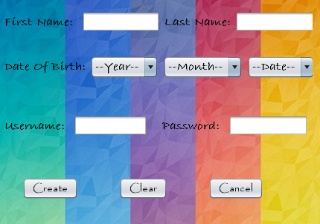

**private void jButton3ActionPerformed(java.awt.event.ActionEvent evt) {**

new Options().setVisible(true);

this.dispose();

**}**

**private void jButton2ActionPerformed(java.awt.event.ActionEvent evt) {**

jTextField1.setText("");

jTextField2.setText("");

jTextField3.setText("");

jPasswordField1.setText("");

**}**

**private void jButton1ActionPerformed(java.awt.event.ActionEvent evt) {**

if(jTextField1.getText().isEmpty()||jTextField2.getText().isEmpty()

||jTextField3.getText().isEmpty()||jPasswordField1.getText().isEmpty()||

jComboBox1.getSelectedIndex()==0||jComboBox2.getSelectedIndex()==0||

jComboBox3.getSelectedIndex()==0){

if(jTextField1.getText().isEmpty()){

JOptionPane.showMessageDialog(this,"Please enter you First Name!" );

}

if(jTextField2.getText().isEmpty()){

JOptionPane.showMessageDialog(this,"Please enter Last Name!" );

}

if(jTextField3.getText().isEmpty()){

JOptionPane.showMessageDialog(this,"Please enter username!" );

}

if(jPasswordField1.getText().isEmpty()){

JOptionPane.showMessageDialog(this,"Please enter password!" );

}

if(jComboBox1.getSelectedIndex()==0){

JOptionPane.showMessageDialog(this,"Please select year!" );

}

if(jComboBox2.getSelectedIndex()==0){

JOptionPane.showMessageDialog(this,"Please select month!" );

}

if(jComboBox1.getSelectedIndex()==0){

JOptionPane.showMessageDialog(this,"Please select date!" );

}

}

else{

try{

String username=jTextField3.getText();

Class.forName("java.sql.DriverManager");

Connection con = (Connection)DriverManager.getConnection("jdbc:mysql://localhost:3306/mrproject","root","");

Statement stmt = (Statement)con.createStatement();

String query = "Select * from user where username='"+username+"';";

ResultSet rs=(ResultSet)stmt.executeQuery(query);

if(rs.first()){

JOptionPane.showMessageDialog(this, "This username already exists. Please try again!");

jTextField3.setText("");

jPasswordField1.setText("");

}

else{

try{

Class.forName("java.sql.DriverManager");

Connection conn = (Connection)DriverManager.getConnection("jdbc:mysql://localhost:3306/mrproject","root","");

Statement stamt = (Statement)con.createStatement();

String fname = jTextField1.getText();

String lname = jTextField2.getText();

String user_name = jTextField3.getText();

String password=jPasswordField1.getText();

String year=(String)jComboBox1.getSelectedItem();

String month=(String)jComboBox2.getSelectedItem();

String day=(String)jComboBox3.getSelectedItem();

String date = year + "/" + month + "/"+ day;

String query1 = "Insert into user values('"+fname+"','"+lname+"','"+date+"','"+user_name+"','"+password+"');";

stmt.executeUpdate(query1);

JOptionPane.showMessageDialog(this, "New user created!");

new Login().setVisible(true);

this.dispose();

jTextField1.setText("");

jTextField2.setText("");

jTextField3.setText("");

jPasswordField1.setText("");

jComboBox1.setSelectedIndex(0);

jComboBox2.setSelectedIndex(0);

jComboBox3.setSelectedIndex(0);

}

catch(Exception e){

JOptionPane.showMessageDialog(this, e.getMessage());

}

}

}

catch(Exception e){

JOptionPane.showMessageDialog(this, e.getMessage());

}

}

**}**

**private void formWindowOpened(java.awt.event.WindowEvent evt) {**

this.setBackground(new Color(0,0,0,0));

**}**

HomePage



**private void jMenuItem1ActionPerformed(java.awt.event.ActionEvent evt) {**

new New_Patient().setVisible(true);

this.dispose();

**}**

**private void jMenuItem2ActionPerformed(java.awt.event.ActionEvent evt) {**

new New_Prescription().setVisible(true);

this.dispose();

**}**

**private void jMenuItem3ActionPerformed(java.awt.event.ActionEvent evt) {**

new New_Bill().setVisible(true);

this.dispose();

**}**

**private void jMenuItem4ActionPerformed(java.awt.event.ActionEvent evt) {**

new New_Doctor().setVisible(true);

this.dispose();

**}**

**private void jMenuItem5ActionPerformed(java.awt.event.ActionEvent evt) {**

int confirm = JOptionPane.showConfirmDialog(this, "Are you sure you want to exit?");

if (confirm == 0) {

System.exit(0);

} **}**

**private void jMenu1ActionPerformed(java.awt.event.ActionEvent evt) {**

this.dispose();

**}**

**private void jMenuItem6ActionPerformed(java.awt.event.ActionEvent evt) {**

new Doctor_Update().setVisible(true);

this.dispose();

**}**

**private void jMenuItem7ActionPerformed(java.awt.event.ActionEvent evt) {**

new Doctor_Delete().setVisible(true);

this.dispose();

**}**

**private void jMenuItem8ActionPerformed(java.awt.event.ActionEvent evt) {**

new Search_Patient().setVisible(true);

this.dispose();

**}**

**private void jMenuItem9ActionPerformed(java.awt.event.ActionEvent evt) {**

new Search_Prescription().setVisible(true);

this.dispose();

**}**

**private void jMenuItem10ActionPerformed(java.awt.event.ActionEvent evt) {**

new Search_Bill().setVisible(true);

this.dispose();

**}**

**private void jMenuItem11ActionPerformed(java.awt.event.ActionEvent evt) {**

new Search_Doctor().setVisible(true);

this.dispose();

**}**

**private void jMenuItem12ActionPerformed(java.awt.event.ActionEvent evt) {**

new View_Patient().setVisible(true);

this.dispose();

**}**

**private void jMenuItem13ActionPerformed(java.awt.event.ActionEvent evt) {**

new View_Prescription().setVisible(true);

this.dispose();

**}**

**private void jMenuItem14ActionPerformed(java.awt.event.ActionEvent evt) {**

new View_Bill().setVisible(true);

this.dispose();

**}**

**private void jMenuItem15ActionPerformed(java.awt.event.ActionEvent evt) {**

new View_Doctor().setVisible(true);

this.dispose();

**}**

**private void jMenuItem16ActionPerformed(java.awt.event.ActionEvent evt) {**

new Print_Prescription().setVisible(true);

this.dispose(); **}**

**private void formWindowOpened(java.awt.event.WindowEvent evt) {**

this.setBackground(new Color(0, 0, 0, 0));

**}**

**private void jMenuItem18ActionPerformed(java.awt.event.ActionEvent evt) {**

new Logout().setVisible(true);

this.dispose();

**}**

**private void jMenuItem17ActionPerformed(java.awt.event.ActionEvent evt) {**

new About_Us().setVisible(true);

this.dispose();

**}**

**private void jMenuItem19ActionPerformed(java.awt.event.ActionEvent evt) {**

new Report().setVisible(true);

this.dispose();

**}**

Logout

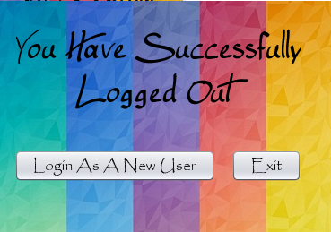

**private void jButton2ActionPerformed(java.awt.event.ActionEvent evt) {**

System.exit(0);

**}**

**private void jButton1ActionPerformed(java.awt.event.ActionEvent evt) {**

new Login().setVisible(true);

this.dispose();

**}**

**private void formWindowOpened(java.awt.event.WindowEvent evt) {**

this.setBackground(new Color(0,0,0,0));

**}**

View Prescription

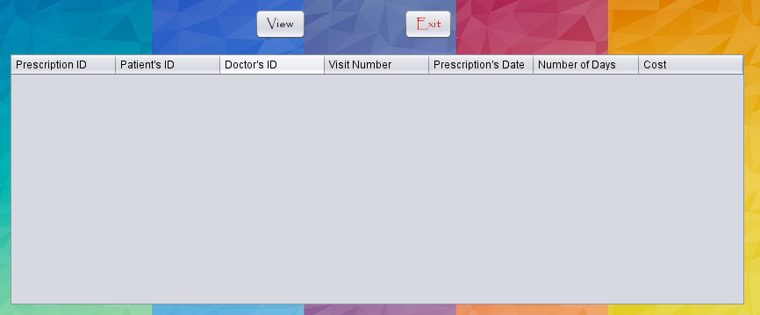

**private void jButton1ActionPerformed(java.awt.event.ActionEvent evt) {**

jTable1.setEnabled(false);

DefaultTableModel table=(DefaultTableModel)jTable1.getModel();

try {

Class.forName("java.sql.DriverManager");

Connection con=(Connection)DriverManager.getConnection("jdbc:mysql://localhost:3306/mrproject","root","");

Statement s =(Statement) con.createStatement();

String q="SELECT * FROM prescription;";

ResultSet rs=s.executeQuery(q);

if(rs.next())

{ rs.previous();

while(rs.next()) {

String pid=rs.getString("pid");

String pno=rs.getString("pno");

String dno=rs.getString("dno");

String visitno=rs.getString("visitno");

String pricp_date=rs.getString("pricp_date");

String days=rs.getString("days");

String cost=rs.getString("cost");

table.addRow(new Object[] {pid,pno,dno,visitno,pricp_date,days,cost});

jButton1.setEnabled(false);

}

}

else

{

JOptionPane.showMessageDialog(this,"No record found...");

}

} catch(Exception e) {JOptionPane.showMessageDialog(this,e.getMessage()); }

**}**

**private void jButton3ActionPerformed(java.awt.event.ActionEvent evt) {**

new HomePage().setVisible(true);

this.dispose();

**}**

**private void formWindowOpened(java.awt.event.WindowEvent evt) {**

this.setBackground(new Color(0,0,0,0));

**}**

View Doctor

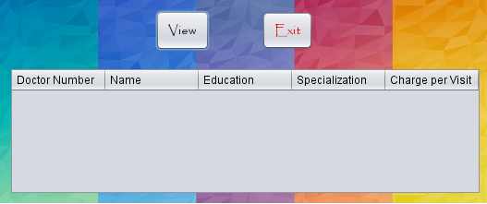

**private void jButton1ActionPerformed(java.awt.event.ActionEvent evt) {**

DefaultTableModel table=(DefaultTableModel)jTable1.getModel();

try {

Class.forName("java.sql.DriverManager");

Connection con=(Connection)DriverManager.getConnection("jdbc:mysql://localhost:3306/mrproject","root","");

Statement s =(Statement) con.createStatement();

String q="SELECT * FROM doctor;";

ResultSet rs=s.executeQuery(q);

if(rs.next())

{ rs.previous();

while(rs.next()) {

String dno=rs.getString("dno"); String d_name=rs.getString("d_name");

String edu=rs.getString("edu"); String spe=rs.getString("specialization");

String charge=rs.getString("charge");

table.addRow(new Object[] {dno,d_name,edu,spe,charge});

jButton1.setEnabled(false);

}

}

else

{

JOptionPane.showMessageDialog(this,"No record found...");

}

} catch(Exception e) {JOptionPane.showMessageDialog(this,e.getMessage()); }

**}**

**private void jButton3ActionPerformed(java.awt.event.ActionEvent evt) {**

new HomePage().setVisible(true);

this.dispose();

**}**

**private void formWindowOpened(java.awt.event.WindowEvent evt) {**

this.setBackground(new Color(0,0,0,0));

**}**

View Patient

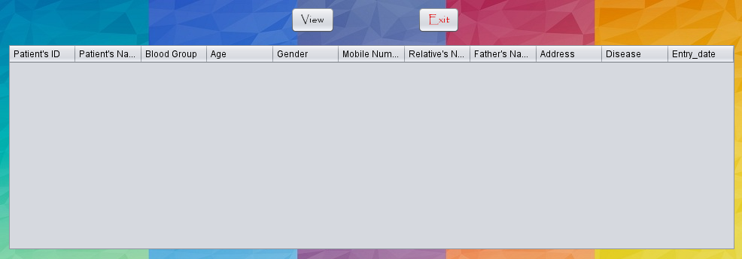

**private void jButton3ActionPerformed(java.awt.event.ActionEvent evt) {**

new HomePage().setVisible(true);

this.dispose();

**}**

**private void jButton1ActionPerformed(java.awt.event.ActionEvent evt) {**

jTable1.setEnabled(false);

DefaultTableModel table=(DefaultTableModel)jTable1.getModel();

try {

Class.forName("java.sql.DriverManager");

Connection con=(Connection)DriverManager.getConnection("jdbc:mysql://localhost:3306/mrproject","root","");

Statement s =(Statement) con.createStatement();

String q="SELECT * FROM patient;";

ResultSet rs=s.executeQuery(q);

if(rs.next())

{ rs.previous();

while(rs.next()) {

String pno=rs.getString("pno");

String p_name=rs.getString("p_name");

String b_gp=rs.getString("b_gp") ;

String age=rs.getString("age") ;

String gender=rs.getString("gender");

String mobileno=rs.getString("mobileno");

String rel_name=rs.getString("rel_name");

String father_name=rs.getString("father_name");

String address=rs.getString("address");

String disease=rs.getString("disease") ;

String en=rs.getString("entry_date");

table.addRow(new Object[] {pno,p_name,b_gp,age,gender,mobileno,rel_name,father_name,address,disease,en});

jButton1.setEnabled(false);

}

}

else

{

JOptionPane.showMessageDialog(this,"No record found...");

}

} catch(Exception e) {JOptionPane.showMessageDialog(this,e.getMessage()); }

**}**

**private void formWindowOpened(java.awt.event.WindowEvent evt) {**

this.setBackground(new Color(0,0,0,0));

**}**

View Bill

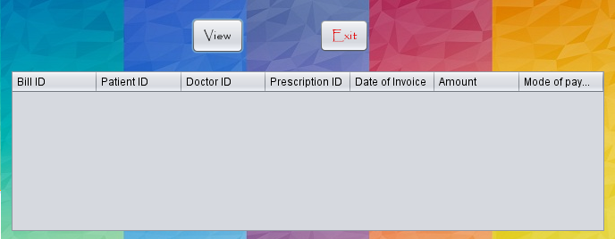

**private void jButton1ActionPerformed(java.awt.event.ActionEvent evt) {**

jTable1.setEnabled(false);

DefaultTableModel table=(DefaultTableModel)jTable1.getModel();

try {

Class.forName("java.sql.DriverManager");

Connection con=(Connection)DriverManager.getConnection("jdbc:mysql://localhost:3306/mrproject","root","");

Statement s =(Statement) con.createStatement();

String q="SELECT * FROM invoice;";

ResultSet rs=s.executeQuery(q);

if(rs.next())

{ rs.previous();

while(rs.next()) {

String inn=rs.getString("inno");

String dno=rs.getString("dno"); String pid=rs.getString("pid");

String pno=rs.getString("pno"); String mode=rs.getString("modepay");

String amount=rs.getString("amount"); String date=rs.getString("bill_date");

table.addRow(new Object[] {inn,pno,dno,pid,date,amount,mode});

jButton1.setEnabled(false);

}

}

else

{

JOptionPane.showMessageDialog(this,"No record found...");

}

} catch(Exception e) {JOptionPane.showMessageDialog(this,e.getMessage()); }

**}**

**private void jButton3ActionPerformed(java.awt.event.ActionEvent evt) {**

new HomePage().setVisible(true);

this.dispose();

**}**

**private void formWindowOpened(java.awt.event.WindowEvent evt) {**

this.setBackground(new Color(0,0,0,0));

**}**

Search Prescription

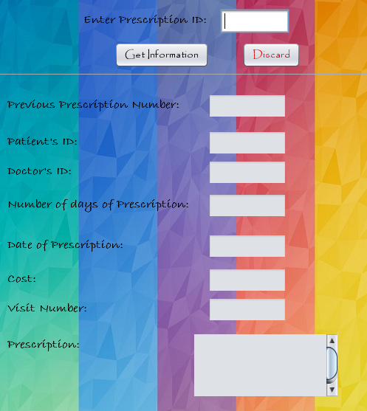

**private void jButton1ActionPerformed(java.awt.event.ActionEvent evt) {**

if(jTextField1.getText().isEmpty())

{

JOptionPane.showMessageDialog(this,"Please enter the Prescription ID...");

}

else

{

try{

Class.forName("java.sql.DriverManager");

Connection con=(Connection)DriverManager.getConnection("jdbc:mysql://localhost:3306/mrproject","root","");

Statement s =(Statement) con.createStatement();

String pricid=jTextField1.getText();

String q="SELECT * FROM prescription WHERE pid='"+pricid+"';";

ResultSet rs=s.executeQuery(q);

if(rs.next())

{

jTextArea1.append(rs.getString("pric"));

jTextField4.setText(rs.getString("days"));

jTextField5.setText(rs.getString("reference"));

jTextField2.setText(rs.getString("pno"));

jTextField3.setText(rs.getString("dno"));

jTextField6.setText(rs.getString("pricp_date"));

jTextField7.setText(rs.getString("cost"));

jTextField8.setText(rs.getString("visitno"));

jTextField1.setEnabled(false);

jButton1.setEnabled(false);

}

else

{

JOptionPane.showMessageDialog(this,"No Record found...");

jTextField1.setText("");

}

} catch(Exception e) {

JOptionPane.showMessageDialog(this, e.getMessage());

}

}

**}**

**private void jTextField1KeyTyped(java.awt.event.KeyEvent evt) {**

char kc=evt.getKeyChar();

if(!((kc>='0'&&kc<='9')||(kc==KeyEvent.VK_BACK_SPACE)||(kc==KeyEvent.VK_DELETE)))

{

JOptionPane.showMessageDialog(this, "Please enter the correct prescription ID.");

evt.consume();

}

**}**

**private void jButton2ActionPerformed(java.awt.event.ActionEvent evt) {**

new HomePage().setVisible(true);

this.dispose();

**}**

**private void formWindowOpened(java.awt.event.WindowEvent evt) {**

this.setBackground(new Color(0,0,0,0));

**}**

Search Patient

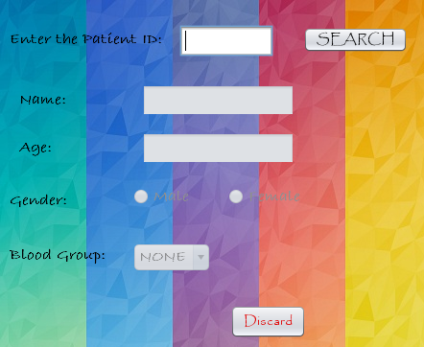

**private void jButton3ActionPerformed(java.awt.event.ActionEvent evt) {**

new HomePage().setVisible(true);

this.dispose();

**}**

**private void jTextField1KeyTyped(java.awt.event.KeyEvent evt) {**

char kc=evt.getKeyChar();

if(!((kc>='0'&&kc<='9')||(kc==KeyEvent.VK_BACK_SPACE)||(kc==KeyEvent.VK_DELETE)))

{

JOptionPane.showMessageDialog(this, "Please enter the correct Patient ID.");

evt.consume();

}

**}**

**private void jButton1ActionPerformed(java.awt.event.ActionEvent evt) {**

if(jTextField1.getText().isEmpty())

{

JOptionPane.showMessageDialog(this,"Please enter a Patient's ID.");

}

else

{ int a=Integer.parseInt(jTextField1.getText());

try{

Class.forName("java.sql.DriverManager");

Connection con=(Connection)DriverManager.getConnection("jdbc:mysql://localhost:3306/mrproject","root","");

Statement s =(Statement) con.createStatement();

String q="SELECT * FROM patient WHERE pno='"+a+"';";

ResultSet rs=s.executeQuery(q);

if(rs.first())

{jButton2.setVisible(true);

jTextField1.setEditable(false);

jTextField2.setText(rs.getString("p_name"));

jTextField3.setText(rs.getString("age"));

String gen=rs.getString("gender");

if(gen.equals("male"))

{

jRadioButton1.setSelected(true);

}

else if(gen.equals("female"))

{

jRadioButton2.setSelected(true);

}

String bgp=rs.getString("b_gp");

if(bgp.equals("A+"))

{jComboBox5.setSelectedIndex(1);}

else if(bgp.equals("B+"))

{jComboBox5.setSelectedIndex(2); }

else if(bgp.equals("O+"))

{jComboBox5.setSelectedIndex(3); }

else if(bgp.equals("AB+"))

{jComboBox5.setSelectedIndex(4); }

else if(bgp.equals("A-"))

{jComboBox5.setSelectedIndex(5); }

else if(bgp.equals("B-"))

{jComboBox5.setSelectedIndex(6); }

else if(bgp.equals("O-"))

{jComboBox5.setSelectedIndex(7); }

else if(bgp.equals("AB-"))

{jComboBox5.setSelectedIndex(8); }

}

else

{

JOptionPane.showMessageDialog(this,"No Record Found...");

jTextField1.setText("");

}

}

catch (Exception e)

{

JOptionPane.showMessageDialog(this, e.getMessage());

}

}

**}**

**private void jButton2ActionPerformed(java.awt.event.ActionEvent evt) {**

String c= jTextField1.getText();

new Search_Patient2(c).setVisible(true);

this.dispose();

**}**

**private void formWindowOpened(java.awt.event.WindowEvent evt) {**

jButton2.setVisible(false);

this.setBackground(new Color(0,0,0,0));

**}**

Search Prescription 2

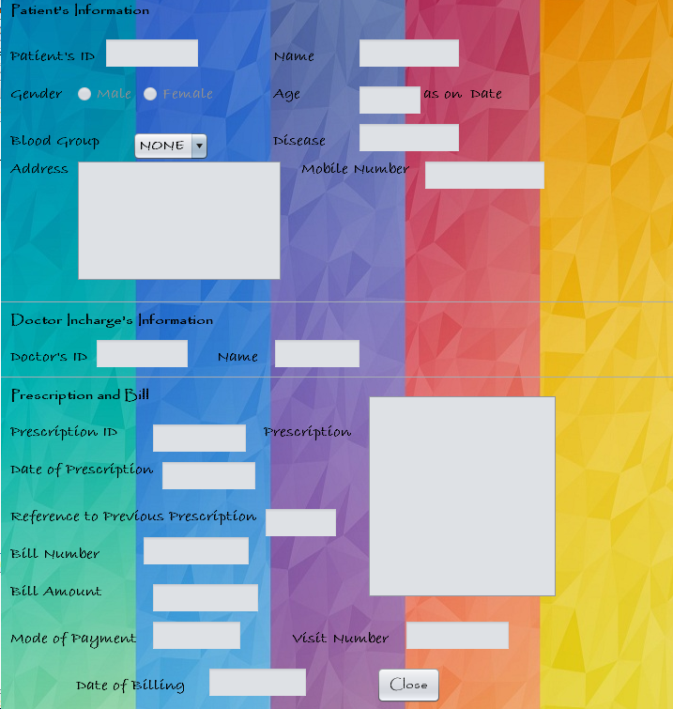

**private void jButton1ActionPerformed(java.awt.event.ActionEvent evt) {**

new HomePage().setVisible(true);

this.dispose();

**}**

**private void formWindowOpened(java.awt.event.WindowEvent evt) {**

this.setBackground(new Color(0,0,0,0));

try{

Class.forName("java.sql.DriverManager");

Connection con=(Connection)DriverManager.getConnection("jdbc:mysql://localhost:3306/mrproject","root","");

Statement s =(Statement) con.createStatement();

String q="SELECT * FROM patient WHERE pno='"+value+"';";

ResultSet rs=s.executeQuery(q);

if(rs.next())

{

String b=rs.getString("b_gp");

jTextField1.setText(rs.getString("p_name"));

jTextField2.setText(rs.getString("age"));

jLabel8.setText(rs.getString("entry_date"));

if(rs.getString("gender").equals("male"))

{ jRadioButton1.setSelected(true);}

else

{jRadioButton2.setSelected(true);}

while(b.equals(jComboBox1.getSelectedItem()))

{ int a=jComboBox1.getSelectedIndex();

jComboBox1.setSelectedIndex(a+1); }

jTextField6.setText(value);

jTextArea1.append(rs.getString("address"));

jTextField3.setText(rs.getString("disease"));

jTextField4.setText(rs.getString("mobileno"));

String q1="SELECT MAX(pid) FROM prescription WHERE pno='"+value+"';";

ResultSet rs1=s.executeQuery(q1);

if(rs1.next())

{ String var=rs1.getString("MAX(pid)");

String q11="SELECT * FROM prescription WHERE pid='"+var+"';";

ResultSet rs11=s.executeQuery(q11);

if(rs11.next())

{ jTextArea2.append(rs11.getString("pric"));

jTextField8.setText(rs11.getString("pid"));

jTextField9.setText(rs11.getString("pricp_date"));

jTextField14.setText(rs11.getString("visitno"));

jTextField5.setText(rs11.getString("dno"));

jTextField15.setText(rs11.getString("reference"));

String q3="SELECT d_name FROM doctor WHERE dno='"+rs11.getString("dno")+"';";

ResultSet rs3=s.executeQuery(q3);

if(rs3.next())

{ jTextField7.setText(rs3.getString("d_name"));

}

String q2="SELECT * FROM invoice WHERE pno='"+value+"';";

ResultSet rs2=s.executeQuery(q2);

if(rs2.next())

{jTextField10.setText(rs2.getString("inno"));

jTextField11.setText(rs2.getString("amount"));

jTextField12.setText(rs2.getString("modepay"));

jTextField13.setText(rs2.getString("bill_date"));

}

else

{

JOptionPane.showMessageDialog(this,"Bill not Paid yet!..");

}

}}

else

{

JOptionPane.showMessageDialog(this,"No Prescription found...");

}

//first patient then prescription then invoice then doctor

}

}

catch(Exception e)

{

JOptionPane.showMessageDialog(this, e.getMessage());

}

**}**

Search Doctor

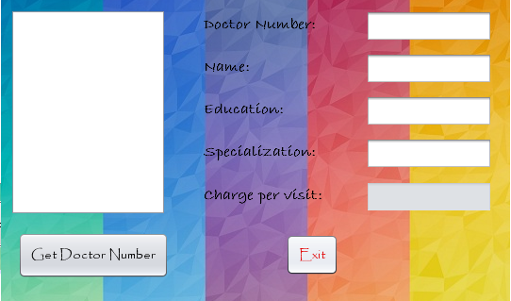

**private void jList1MouseClicked(java.awt.event.MouseEvent evt) {**

if(jList1.getSelectedIndex()<0) {

JOptionPane.showMessageDialog(this,"Please select a doctor number.");}

else {

try{

Class.forName("java.sql.DriverManager");

Connection con=(Connection)DriverManager.getConnection("jdbc:mysql://localhost:3306/mrproject","root","");

Statement s =(Statement) con.createStatement();

String dno=(String)jList1.getSelectedValue();

String q1="SELECT dno,d_name,edu,specialization,charge FROM doctor WHERE dno='"+dno+"';";

ResultSet rs=s.executeQuery(q1);

if(rs.next()) {

jTextField5.setText(rs.getString("charge"));

jTextField1.setText(rs.getString("dno"));

jTextField2.setText(rs.getString("d_name"));

jTextField3.setText(rs.getString("edu"));

jTextField4.setText(rs.getString("specialization"));

jTextField5.setText(rs.getString("charge"));

}

} catch(Exception ae) {

JOptionPane.showMessageDialog(this,ae.getMessage());

}

}

**}**

**private void jButton1ActionPerformed(java.awt.event.ActionEvent evt) {**

jButton1.setEnabled(false);

DefaultListModel list =(DefaultListModel)jList1.getModel();

try{

Class.forName("java.sql.DriverManager");

Connection con=(Connection)DriverManager.getConnection("jdbc:mysql://localhost:3306/mrproject","root","");

Statement s =(Statement) con.createStatement();

String q="SELECT dno FROM doctor ;";

ResultSet rs=s.executeQuery(q);

if(rs.next())

{ rs.previous();

while(rs.next()) {

String dno =rs.getString("dno");

list.addElement(dno);

}

}

else

{

JOptionPane.showMessageDialog(this,"No record found...");

jButton1.setVisible(true);

}

} catch(Exception ea) {

JOptionPane.showMessageDialog(this, ea.getMessage());

}

**}**

**private void jButton2ActionPerformed(java.awt.event.ActionEvent evt) {**

new HomePage().setVisible(true);

this.dispose();

**}**

**private void formWindowOpened(java.awt.event.WindowEvent evt) {**

this.setBackground(new Color(0,0,0,0));

**}**

Search Bill

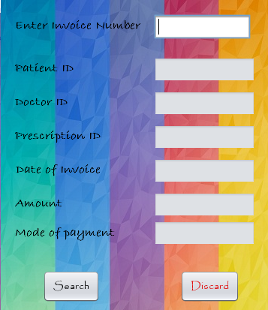

**private void jButton3ActionPerformed(java.awt.event.ActionEvent evt) {**

new HomePage().setVisible(true);

this.dispose();

**}**

**private void jButton1ActionPerformed(java.awt.event.ActionEvent evt) {**

if(jTextField1.getText().isEmpty()) {

JOptionPane.showMessageDialog(this,"Please enter the Invoice Number."); }

else{

try {

String inno=(String)jTextField1.getText();

Class.forName("java.sql.DriverManager");

Connection con=(Connection)DriverManager.getConnection("jdbc:mysql://localhost:3306/mrproject","root","");

Statement s =(Statement) con.createStatement();

String q="SELECT * FROM invoice WHERE inno='"+inno+"';";

ResultSet rs=s.executeQuery(q);

if(rs.next()) {

jTextField2.setText(rs.getString("pno"));

jTextField3.setText(rs.getString("dno"));

jTextField4.setText(rs.getString("dno"));

jTextField5.setText(rs.getString("bill_date"));

jTextField6.setText(rs.getString("amount"));

jTextField7.setText(rs.getString("modepay"));

jButton1.setEnabled(false);

jTextField1.setEditable(false);

}

else

{ jButton1.setEnabled(true);

JOptionPane.showMessageDialog(this,"No record found.");

jTextField1.setText("");

}

} catch(Exception e) {

JOptionPane.showMessageDialog(this, e.getMessage()); }

}

**}**

**private void jTextField1KeyTyped(java.awt.event.KeyEvent evt) {**

char kc=evt.getKeyChar();

if(!((kc>='0'&&kc<='9')||(kc==KeyEvent.VK_BACK_SPACE)||(kc==KeyEvent.VK_DELETE)))

{

JOptionPane.showMessageDialog(this, "Please enter the correct Invoice Number.");

evt.consume();

}

**}**

**private void formWindowOpened(java.awt.event.WindowEvent evt) {**

this.setBackground(new Color(0,0,0,0));

**}**

Print Prescription

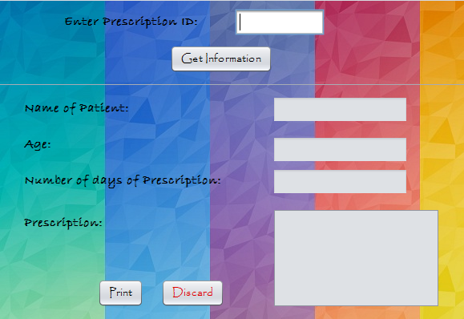

**private void jButton2ActionPerformed(java.awt.event.ActionEvent evt) {**

try{

Class.forName("java.sql.DriverManager");

Connection con=(Connection)DriverManager.getConnection("jdbc:mysql://localhost:3306/mrproject","root","");

Statement s =(Statement) con.createStatement();

String pricid=jTextField1.getText();

String q="SELECT * FROM prescription WHERE pid='"+pricid+"';";

ResultSet rs=s.executeQuery(q);

if(rs.next())

{

String pno=rs.getString("pno");

String days=rs.getString("days");

String pric=rs.getString("pric");

String q1="SELECT * FROM patient WHERE pno='"+pno+"';";

ResultSet rs1=s.executeQuery(q1);

if(rs1.next())

{

String p_name =rs1.getString("p_name");

String age=rs1.getString("age");

new Print_Prescription2(p_name,age,days,pric).setVisible(true);

this.dispose();

}

}

}

catch(Exception e)

{

JOptionPane.showMessageDialog(this, e.getMessage());

}

**}**

**private void jButton4ActionPerformed(java.awt.event.ActionEvent evt) {**

new HomePage().setVisible(true);

this.dispose();

**}**

**private void jTextField1KeyTyped(java.awt.event.KeyEvent evt) {**

char kc=evt.getKeyChar();

if(!((kc>='0'&&kc<='9')||(kc==KeyEvent.VK_BACK_SPACE)||(kc==KeyEvent.VK_DELETE)))

{

JOptionPane.showMessageDialog(this, "Please enter the correct Prescription ID.");

evt.consume();

}

**}**

**private void jButton1ActionPerformed(java.awt.event.ActionEvent evt) {**

if(jTextField1.getText().isEmpty())

{

JOptionPane.showMessageDialog(this,"Please enter the Prescription ID...");

jLabel6.setVisible(true);

}

else

{jLabel6.setVisible(false);

try{

Class.forName("java.sql.DriverManager");

Connection con=(Connection)DriverManager.getConnection("jdbc:mysql://localhost:3306/mrproject","root","");

Statement s =(Statement)con.createStatement();

String pricid=jTextField1.getText();

String q="SELECT * FROM prescription WHERE pid='"+pricid+"';";

ResultSet rs=s.executeQuery(q);

if(rs.next())

{ String pno=rs.getString("pno");

jTextField4.setText(rs.getString("days"));

jTextArea1.setText(rs.getString("pric"));

String q1="SELECT * FROM patient WHERE pno='"+pno+"';";

ResultSet rs1=s.executeQuery(q1);

if(rs1.next())

{

jTextField2.setText(rs1.getString("p_name"));

jTextField3.setText(rs1.getString("age"));

}

jButton1.setEnabled(false);

jTextField1.setEditable(false);

}

else

{jTextField1.setText("");

JOptionPane.showMessageDialog(this,"No record found...");

}

}

catch(Exception e)

{

JOptionPane.showMessageDialog(this, e.getMessage());

}

}

**}**

**private void formWindowOpened(java.awt.event.WindowEvent evt) {**

jLabel6.setVisible(false);

**}**

Print Prescription 2

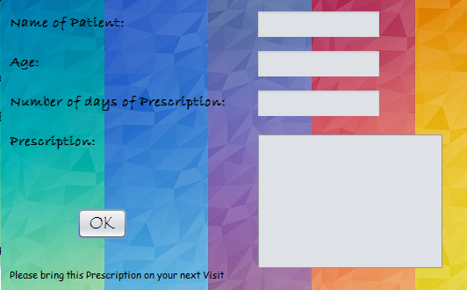

**private void jButton2ActionPerformed(java.awt.event.ActionEvent evt) {**

jTextArea1.setText("");

jTextField2.setText("");

jTextField3.setText("");

jTextField4.setText("");

JOptionPane.showMessageDialog(this,"Pricsription Printed Sucessfully...");

new HomePage().setVisible(true);

this.dispose();

**}**

**private void formWindowOpened(java.awt.event.WindowEvent evt) {**

jTextField2.setText(p_name1);

jTextField3.setText(age1);

jTextField4.setText(days1);

jTextArea1.append(pric1);

**}**

New Prescription

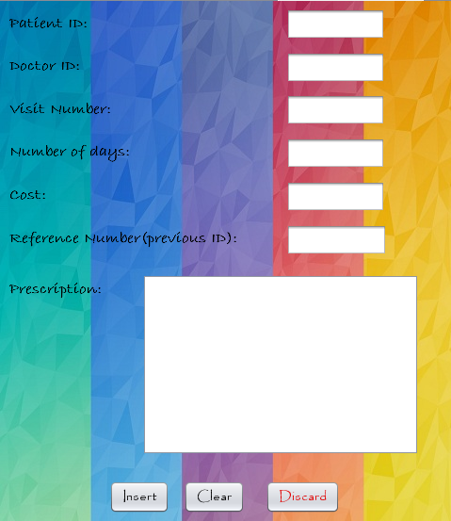

**private void jTextField4KeyTyped(java.awt.event.KeyEvent evt) {**

char kc=evt.getKeyChar();

if(!((kc>='0'&&kc<='9')||(kc==KeyEvent.VK_BACK_SPACE)||(kc==KeyEvent.VK_DELETE))) {

JOptionPane.showMessageDialog(this, "Please enter the Total Days of Prescription.");

evt.consume();

}

**}**

**private void jTextField2KeyTyped(java.awt.event.KeyEvent evt) {**

char kc=evt.getKeyChar();

if(!((kc>='0'&&kc<='9')||(kc==KeyEvent.VK_BACK_SPACE)||(kc==KeyEvent.VK_DELETE))) {

JOptionPane.showMessageDialog(this, "Please enter the correct Doctor's ID.");

evt.consume();

}

**}**

**private void jTextField5KeyTyped(java.awt.event.KeyEvent evt) {**

char kc=evt.getKeyChar();

if(!((kc>='0'&&kc<='9')||(kc==KeyEvent.VK_BACK_SPACE)||(kc==KeyEvent.VK_DELETE))) {

JOptionPane.showMessageDialog(this, "Please enter the correct Cost.");

evt.consume();

}

**}**

**private void jTextField3KeyTyped(java.awt.event.KeyEvent evt) {**

char kc=evt.getKeyChar();

if(!((kc>='0'&&kc<='9')||(kc==KeyEvent.VK_BACK_SPACE)||(kc==KeyEvent.VK_DELETE))) {

JOptionPane.showMessageDialog(this, "Please enter the correct Visit Number.");

evt.consume();

}

**}**

**private void jButton1ActionPerformed(java.awt.event.ActionEvent evt) {**

Calendar c=Calendar.getInstance();

int cur_year=c.get(Calendar.YEAR);

int cur_month=c.get(Calendar.MONTH)+1;

int cur_day=c.get(Calendar.DAY_OF_MONTH);

String cm,cd;

if (cur_month<10) {

cm=""+0+cur_month; } else{ cm=""+cur_month; }

if(cur_day<10)

{ cd=""+0+cur_day; } else { cd=""+cur_day;}

String date=cur_year+cm+cd;

if(jTextArea1.getText().isEmpty()||jTextField1.getText().isEmpty()||jTextField2.getText().isEmpty()

||jTextField3.getText().isEmpty()||jTextField4.getText().isEmpty()||jTextField5.getText().isEmpty()) {

if(jTextField1.getText().isEmpty()) {

jLabel7.setVisible(true);}

if(jTextField2.getText().isEmpty()) {

jLabel8.setVisible(true);}

if(jTextField3.getText().isEmpty()) {

jLabel9.setVisible(true);}

if(jTextField4.getText().isEmpty()) {

jLabel10.setVisible(true);}

if(jTextField5.getText().isEmpty()) {

jLabel1.setVisible(true);}

if(jTextArea1.getText().isEmpty()) {

jLabel12.setVisible(true);}

JOptionPane.showMessageDialog(this,"Plase enter the indicated values.");

}

else if(jTextField1.getText().equals("0")||jTextField2.getText().equals("0")||jTextField3.getText().equals("0")||jTextField4.getText().equals("0")||jTextField5.getText().equals("0")||jTextArea1.getText().equals("0")) {

if(jTextField1.getText().equals("0")) {

jLabel7.setVisible(true);

jTextField1.setText("");}

if(jTextField2.getText().equals("0")) {

jLabel8.setVisible(true);

jTextField2.setText("");}

if(jTextField3.getText().equals("0")) {

jLabel9.setVisible(true);

jTextField3.setText("");}

if(jTextField4.getText().equals("0")) {

jLabel10.setVisible(true);

jTextField4.setText("");}

if(jTextField5.getText().equals("0")) {

jLabel11.setVisible(true);

jTextField5.setText("");}

if(jTextField6.getText().equals("0")) {

jLabel14.setVisible(true);

jTextField6.setText("");}

if(jTextArea1.getText().equals("0")) {

jLabel12.setVisible(true);}

JOptionPane.showMessageDialog(this,"Please enter the indicated information.");

}

else if(jTextField1.getText().startsWith("0")||jTextField2.getText().startsWith("0")||jTextField3.getText().startsWith("0")||jTextField4.getText().startsWith("0")||jTextField5.getText().startsWith("0")/*||jTextField6.getText().startsWith("0")*/) {

if(jTextField1.getText().startsWith("0")) {

jTextField1.setText("");

jLabel7.setVisible(true);}

if(jTextField2.getText().startsWith("0")) {

jTextField2.setText("");

jLabel8.setVisible(true);}

if(jTextField3.getText().startsWith("0")) {

jTextField3.setText("");

jLabel9.setVisible(true);}

if(jTextField4.getText().startsWith("0")) {

jTextField4.setText("");

jLabel10.setVisible(true);}

if(jTextField5.getText().startsWith("0")) {

jTextField5.setText("");

jLabel11.setVisible(true);}

if(jTextField6.getText().startsWith("0")) {

jTextField6.setText("");

jLabel14.setVisible(true);}

JOptionPane.showMessageDialog(this,"Please enter the selected value(s) again with no '0' in the begining.");

}

else if(Integer.parseInt(jTextField3.getText())==1&&!(jTextField6.getText().isEmpty())) {

JOptionPane.showMessageDialog(this,"Please press insert again.");

jTextField6.setText("");

}

else if(Integer.parseInt(jTextField3.getText())!=1&&jTextField6.getText().isEmpty()) {

JOptionPane.showMessageDialog(this,"Please enter selected value.");

jLabel14.setVisible(true);}

else if(Integer.parseInt(jTextField4.getText())>45)

{

JOptionPane.showMessageDialog(this,"Please don't give prescription for such a long time.");

jTextField4.setText("");

}

else

{

jLabel7.setVisible(false);

jLabel8.setVisible(false);

jLabel9.setVisible(false);

jLabel10.setVisible(false);

jLabel11.setVisible(false);

jLabel12.setVisible(false);

jLabel14.setVisible(false);

int confirm=JOptionPane.showConfirmDialog(this,"Do you want to make an entry?","Confirm Details",JOptionPane.YES_NO_OPTION);

if(confirm==0) {

try

{

Class.forName("java.sql.DriverManager");

Connection conn=(Connection)DriverManager.getConnection("jdbc:mysql://localhost:3306/mrproject","root","");

Statement s=conn.createStatement();

String pno=jTextField1.getText();

String dno=jTextField2.getText();

String vno=jTextField3.getText();

String nod=jTextField4.getText();

String cost=jTextField5.getText();

String pres=jTextArea1.getText();

String ref=jTextField6.getText();

int vnoi = Integer.parseInt(vno);

int pnoin= Integer.parseInt(pno);

int dnoin= Integer.parseInt(dno);

String patientcheck="SELECT MAX(pno) FROM patient;";

ResultSet patientcheckrs=s.executeQuery(patientcheck);

if(patientcheckrs.next())

{

if(Integer.parseInt(pno)>Integer.parseInt(patientcheckrs.getString("MAX(pno)")))

{ JOptionPane.showMessageDialog(this,"ERROR: \n No patient ID Found in the record.");

jTextField1.setText("");

jLabel7.setVisible(true);

}

else

{

String doccheck="SELECT MAX(dno) FROM doctor;";

ResultSet doccheckrs=s.executeQuery(doccheck);

if(doccheckrs.next())

{

if(Integer.parseInt(dno)> Integer.parseInt(doccheckrs.getString("MAX(dno)")))

{

JOptionPane.showMessageDialog(this,"ERROR: \n No Doctor with such ID Found in the record.");

jTextField2.setText("");

jLabel8.setVisible(true);

}

else

{

if(!(jTextField6.getText().isEmpty()))

{ String refi=jTextField6.getText();

String check="SELECT pno,dno,MAX(visitno) FROM prescription WHERE pid='"+refi+"';";

ResultSet rscheck=s.executeQuery(check);

if(rscheck.next())

{

int pnoi= Integer.parseInt(rscheck.getString("pno"));

int dnoi= Integer.parseInt(rscheck.getString("dno"));

int visitnoi= Integer.parseInt(rscheck.getString("MAX(visitno)"));

int visitnoin=visitnoi+1;

if((pnoi==pnoin)&&(dnoi==dnoin)&&(visitnoin==vnoi))

{

String q1="INSERT INTO prescription (pno,dno,pric,visitno,pricp_date,days,cost,reference) VALUES ('"+pno+"','"+dno+"','"+pres+"','"+vno+"','"+date+"','"+nod+"','"+cost+"','"+ref+"');";

s.executeUpdate(q1);

String q1_get="SELECT MAX(pid) FROM prescription;";

ResultSet rsget=s.executeQuery(q1_get);

if(rsget.next()) {

String Pres_id=rsget.getString("MAX(pid)");

JOptionPane.showMessageDialog(this,"Data insertion sucessful.."+"\n The prescription's ID is "+Pres_id);

}

new HomePage().setVisible(true);

this.dispose();

}

else

{ JOptionPane.showMessageDialog(this,"ERROR: \n The Entries Made Does not match with that of previous Prescription ID. \n Please enter the Indicated Entries again.");

jTextField1.setText("");

jTextField2.setText("");

jTextField6.setText("");

jTextField3.setText(visitnoin+"");

jLabel7.setVisible(true);

jLabel8.setVisible(true);

jLabel14.setVisible(true); }

}

}

else

{

String q2="INSERT INTO prescription (pno,dno,pric,visitno,pricp_date,days,cost,reference) VALUES ('"+pno+"','"+dno+"','"+pres+"','"+vno+"','"+date+"','"+nod+"','"+cost+"',NULL);";

s.executeUpdate(q2);

String q2_get="SELECT MAX(pid) FROM prescription;";

ResultSet rsget2=s.executeQuery(q2_get);

if(rsget2.next()) {

String Pres_id=rsget2.getString("MAX(pid)");

JOptionPane.showMessageDialog(this,"Data insertion sucessful.."+"\n The prescription's ID is "+Pres_id);

}

new HomePage().setVisible(true);

this.dispose();

}

}

}

else

{ JOptionPane.showMessageDialog(this,"ERROR: \n No Doctor with such ID Found in the record.");

jTextField2.setText("");

jLabel8.setVisible(true);

}

}

}

else

{

JOptionPane.showMessageDialog(this,"ERROR: \n No patient ID Found in the record.");

jTextField1.setText("");

jLabel7.setVisible(true);

}

}

catch(Exception e)

{JOptionPane.showMessageDialog(this,"error");

JOptionPane.showMessageDialog(this,e.getMessage());

}

}

else

{ }

}

**}**

**private void jButton2ActionPerformed(java.awt.event.ActionEvent evt) {**

jLabel12.setVisible(false);

jLabel7.setVisible(false);

jLabel14.setVisible(false);

jLabel8.setVisible(false);

jLabel9.setVisible(false);

jLabel10.setVisible(false);

jLabel11.setVisible(false);

jTextField1.setText("");

jTextField2.setText("");

jTextField3.setText("");

jTextField4.setText("");

jTextField5.setText("");

jTextField6.setText("");

jTextArea1.setText("");

**}**

**private void jButton3ActionPerformed(java.awt.event.ActionEvent evt) {**

new HomePage().setVisible(true);

this.dispose();

**}**

**private void jTextField1KeyTyped(java.awt.event.KeyEvent evt) {**

char kc=evt.getKeyChar();

if(!((kc>='0'&&kc<='9')||(kc==KeyEvent.VK_BACK_SPACE)||(kc==KeyEvent.VK_DELETE))) {

JOptionPane.showMessageDialog(this, "Please enter the correct Patient's ID.");

evt.consume();

}

**}**

**private void formWindowOpened(java.awt.event.WindowEvent evt) {**

this.setBackground(new Color(0,0,0,0));

jLabel12.setVisible(false);

jLabel7.setVisible(false);

jLabel14.setVisible(false);

jLabel8.setVisible(false);

jLabel9.setVisible(false);

jLabel10.setVisible(false);

jLabel11.setVisible(false);

**}**

**private void jTextField6KeyTyped(java.awt.event.KeyEvent evt) {**

char kc=evt.getKeyChar();

if(!((kc>='0'&&kc<='9')||(kc==KeyEvent.VK_BACK_SPACE)||(kc==KeyEvent.VK_DELETE))) {

JOptionPane.showMessageDialog(this, "Please enter the correct reference Number.");

evt.consume();

}

**}**

New Patient

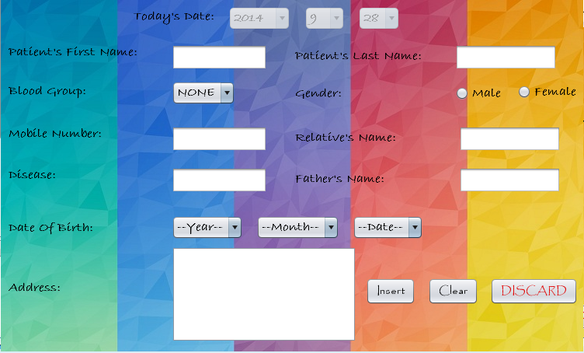

**private void jTextField6KeyTyped(java.awt.event.KeyEvent evt) {**

char kc=evt.getKeyChar();

if(!((kc>='a'&&kc<='z')||(kc==KeyEvent.VK_BACK_SPACE)||(kc==KeyEvent.VK_DELETE)

||(kc>='A'&&kc<='Z')||(kc=='.')||(kc==KeyEvent.VK_SPACE))) {

JOptionPane.showMessageDialog(this, "Please enter the correct Name.");

evt.consume();

}

**}**

**private void jTextField8KeyTyped(java.awt.event.KeyEvent evt) {**

char kc=evt.getKeyChar();

if(!((kc>='a'&&kc<='z')||(kc==KeyEvent.VK_BACK_SPACE)||(kc==KeyEvent.VK_DELETE)

||(kc>='A'&&kc<='Z')||(kc=='.')||(kc==KeyEvent.VK_SPACE))) {

JOptionPane.showMessageDialog(this, "Please enter the correct Name.");

evt.consume();

}

**}**

**private void jButton3ActionPerformed(java.awt.event.ActionEvent evt) {**

new HomePage().setVisible(true);

this.dispose();

**}**

**private void jButton1ActionPerformed(java.awt.event.ActionEvent evt) {**

Star1.setVisible(false);

Star2.setVisible(false);

Star3.setVisible(false);

Star4.setVisible(false);

Star5.setVisible(false);

Star9.setVisible(false);

Star6.setVisible(false);

Star7.setVisible(false);

Star8.setVisible(false);

Star10.setVisible(false);

Calendar c=Calendar.getInstance();

int cur_year=c.get(Calendar.YEAR);

int cur_month=c.get(Calendar.MONTH)+1;

int cur_day=c.get(Calendar.DAY_OF_MONTH);

String cm,cd;

if (cur_month<10) {

cm=""+0+cur_month; } else{ cm=""+cur_month; }

if(cur_day<10)

{ cd=""+0+cur_day; } else { cd=""+cur_day;}

String date=cur_year+cm+cd;

DefaultComboBoxModel com=(DefaultComboBoxModel)jComboBox4.getModel();

DefaultComboBoxModel com1=(DefaultComboBoxModel)jComboBox5.getModel();

DefaultComboBoxModel com2=(DefaultComboBoxModel)jComboBox6.getModel();

DefaultComboBoxModel com3=(DefaultComboBoxModel)jComboBox7.getModel();

String dy= (String)jComboBox5.getSelectedItem();

int y = Integer.parseInt(dy);

int ay= cur_year-(y);

String dm= (String)jComboBox6.getSelectedItem();

int m = Integer.parseInt(dm);

int am= cur_month-(m);

String dd= (String)jComboBox7.getSelectedItem();

int d = Integer.parseInt(dd);

int ad= cur_day-(d);

int age=0;

if(am<0){

age = ay - 1;

}

else if(am>0)

{

age = ay;

}

else if(am==0){

if(ad<0){

age = ay - 1;

}

else if(ad>=0){

age = ay;

}

}

String final_age = String.valueOf(age);

if(jTextField1.getText().isEmpty()||jTextField2.getText().isEmpty()||jComboBox4.getSelectedIndex()==0||

jTextField5.getText().isEmpty()||jTextField6.getText().isEmpty()||jTextField8.getText().isEmpty()||

jTextField10.getText().isEmpty()||jComboBox5.getSelectedIndex()==0||

jComboBox6.getSelectedIndex()==0||jComboBox7.getSelectedIndex()==0||jTextArea1.getText().isEmpty()) {

if(jTextField1.getText().isEmpty()) {

Star1.setVisible(true);}

if(jTextField2.getText().isEmpty()) {

Star2.setVisible(true);}

if(jComboBox4.getSelectedIndex()==0) {

Star3.setVisible(true);}

if(jComboBox5.getSelectedIndex()==0||jComboBox6.getSelectedIndex()==0||jComboBox7.getSelectedIndex()==0) {

Star4.setVisible(true);}

if(jTextField5.getText().isEmpty()) {

Star5.setVisible(true);}

if(jTextField6.getText().isEmpty()) {

Star8.setVisible(true);}

if(jTextField8.getText().isEmpty()) {

Star9.setVisible(true);}

if(jTextField10.getText().isEmpty()) {

Star6.setVisible(true);}

if(!(jRadioButton1.isSelected())&&!(jRadioButton2.isSelected())) {

Star7.setVisible(true);}

JOptionPane.showMessageDialog(this,"Please Enter the indicated values.");

}

if(jTextArea1.getText().isEmpty()) {

Star10.setVisible(true);}

else if(jTextField5.getText().length()!=10) {

JOptionPane.showMessageDialog(this,"Please enter the correct mobile Number.");

jTextField5.setText("");

}

else if(jTextField5.getText().startsWith("0"))

{

JOptionPane.showMessageDialog(this,"Please enter the mobile number correctly.");

jTextField5.setText("");

Star5.setVisible(true);

}

else if(jTextField6.getText().startsWith(" ")||jTextField8.getText().startsWith(" "))

{

if(jTextField6.getText().startsWith(" "))

{

jTextField6.setText("");

Star8.setVisible(true);

}

else if(jTextField8.getText().startsWith(" "))

{

jTextField8.setText("");

Star9.setVisible(true);

}

JOptionPane.showMessageDialog(this,"Please enter the indicated fields properly.");

}

else {

int confirm=JOptionPane.showConfirmDialog(this,"Do you want to make an entry ?","Confirm Details",JOptionPane.YES_NO_OPTION);

if(confirm==0) {

try {

Star1.setVisible(false); Star3.setVisible(false);

Star6.setVisible(false); Star4.setVisible(false);

Star7.setVisible(false); Star5.setVisible(false);

Star8.setVisible(false); Star9.setVisible(false);

Star2.setVisible(false);

String fname=jTextField1.getText();

String sname=jTextField2.getText();

String name=fname+" "+sname;

String bg=(String) com.getSelectedItem();

String disease=jTextField10.getText();

String mobileno=jTextField5.getText();

String reln=jTextField6.getText();

String fathern=jTextField8.getText();

String add=jTextArea1.getText();

Class.forName("java.sql.DriverManager");

Connection con=(Connection)DriverManager.getConnection("jdbc:mysql://localhost:3306/mrproject","root","");

Statement s =(Statement) con.createStatement();

if(jRadioButton1.isSelected()) {

String gender="male";

String q="INSERT INTO patient (p_name,b_gp,age,gender,rel_name,father_name,address,disease,mobileno,entry_date) VALUES('"+name+"','"+bg+"','"+final_age+"','"+gender+"','"+reln+"','"+fathern+"','"+add+"','"+disease+"','"+mobileno+"','"+date+"');";

s.executeUpdate(q);}

else if(jRadioButton2.isSelected()) {

String gender="female";

String q="INSERT INTO patient (p_name,b_gp,age,gender,rel_name,father_name,address,disease,mobileno,entry_date) VALUES('"+name+"','"+bg+"','"+final_age+"','"+gender+"','"+reln+"',"+fathern+"','"+add+"','"+disease+"','"+mobileno+"','"+date+"');";

s.executeUpdate(q);}

String q1="SELECT MAX(pno) FROM patient;";

ResultSet rs1=s.executeQuery(q1);

if(rs1.next())

{

String Patient_id=rs1.getString("MAX(pno)");

JOptionPane.showMessageDialog(this,"Insertion sucessful..."+"\n The Patient's ID is "+Patient_id);

}

new HomePage().setVisible(true);

this.dispose();

} catch (Exception e) {JOptionPane.showMessageDialog(this, e.getMessage()); }

} else{ }

}

**}**

**private void jButton2ActionPerformed(java.awt.event.ActionEvent evt) {**

jTextArea1.setText("");

jTextField1.setText("");

buttonGroup1.clearSelection();

jComboBox4.setSelectedIndex(0);

jComboBox5.setSelectedIndex(0);

jComboBox6.setSelectedIndex(0);

jComboBox7.setSelectedIndex(0);

buttonGroup1.clearSelection();

jTextField2.setText("");

jTextField5.setText("");

jTextField6.setText("");

jTextField8.setText("");

jTextField10.setText("");

Star1.setVisible(false);

Star2.setVisible(false);

Star3.setVisible(false);

Star4.setVisible(false);

Star5.setVisible(false);

Star6.setVisible(false);

Star7.setVisible(false);

Star8.setVisible(false);

Star9.setVisible(false);

Star10.setVisible(false);

**}**

**private void jTextField10KeyTyped(java.awt.event.KeyEvent evt) {**

char kc=evt.getKeyChar();

if(!((kc>='a'&&kc<='z')||(kc==KeyEvent.VK_BACK_SPACE)||(kc==KeyEvent.VK_DELETE))) {

JOptionPane.showMessageDialog(this, "Please enter the disease.");

evt.consume();

}

**}**

**private void jTextField2KeyTyped(java.awt.event.KeyEvent evt) {**

char kc=evt.getKeyChar();

if(!((kc>='a'&&kc<='z')||(kc==KeyEvent.VK_BACK_SPACE)||(kc==KeyEvent.VK_DELETE)

||(kc>='A'&&kc<='Z')||(kc=='.'))) {

JOptionPane.showMessageDialog(this, "Please enter the correct name of the Patient.");

evt.consume();

}

**}**

**private void jTextField1KeyTyped(java.awt.event.KeyEvent evt) {**

char kc=evt.getKeyChar();

if(!((kc>='a'&&kc<='z')||(kc==KeyEvent.VK_BACK_SPACE)||(kc==KeyEvent.VK_DELETE)

||(kc>='A'&&kc<='Z')||(kc=='.'))) {

JOptionPane.showMessageDialog(this, "Please enter the correct name of the Patient.");

evt.consume();

}

**}**

**private void jTextField5KeyTyped(java.awt.event.KeyEvent evt) {**

char kc=evt.getKeyChar();

if(!((kc>='0'&&kc<='9')||(kc==KeyEvent.VK_BACK_SPACE)||(kc==KeyEvent.VK_DELETE)))

{

JOptionPane.showMessageDialog(this, "Please enter the correct mobile number.");

evt.consume();

}

**}**

**private void formWindowOpened(java.awt.event.WindowEvent evt) {**

this.setBackground(new Color(0,0,0,0));

jComboBox1.setEnabled(false);

jComboBox2.setEnabled(false);

jComboBox3.setEnabled(false);

Calendar c = new GregorianCalendar();

int month =c.get(Calendar.MONTH);

int year =c.get(Calendar.YEAR);

int day =c.get(Calendar.DAY_OF_MONTH);

while(year>=1990)

{

jComboBox1.addItem(year);

year--;

}

jComboBox2.setSelectedIndex(month);

jComboBox3.setSelectedIndex(day-1);

Star1.setVisible(false);

Star2.setVisible(false);

Star3.setVisible(false);

Star4.setVisible(false);

Star5.setVisible(false);

Star6.setVisible(false);

Star7.setVisible(false);

Star8.setVisible(false);

Star9.setVisible(false);

Star10.setVisible(false);

**}**

New Doctor

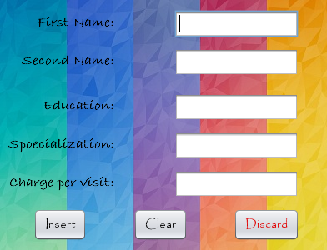

**private void jTextField1KeyTyped(java.awt.event.KeyEvent evt) {**

char kc=evt.getKeyChar();

if(!((kc>='a'&&kc<='z')||(kc>='A'&&kc<='Z')||(kc==KeyEvent.VK_BACK_SPACE)||(kc==KeyEvent.VK_DELETE)||(kc=='.')))

{

JOptionPane.showMessageDialog(this, "Please enter the correct last name.");

evt.consume();

}

**}**

**private void jButton2ActionPerformed(java.awt.event.ActionEvent evt) {**

jTextField1.setText("");

jTextField2.setText("");

jTextField3.setText("");

jTextField4.setText("");

jTextField5.setText("");

jLabel7.setVisible(false);

jLabel2.setVisible(false);

jLabel8.setVisible(false);

jLabel9.setVisible(false);

jLabel11.setVisible(false);

**}**

**private void jButton1ActionPerformed(java.awt.event.ActionEvent evt) {**

if(jTextField2.getText().isEmpty()||jTextField1.getText().isEmpty()||

jTextField3.getText().isEmpty()||jTextField4.getText().isEmpty()||jTextField5.getText().isEmpty())

{

if(jTextField2.getText().isEmpty())

{ jLabel7.setVisible(true); }

if(jTextField1.getText().isEmpty())

{ jLabel2.setVisible(true); }

if(jTextField3.getText().isEmpty())

{ jLabel8.setVisible(true); }

if(jTextField4.getText().isEmpty())

{ jLabel9.setVisible(true); }

if(jTextField5.getText().isEmpty())

{ jLabel11.setVisible(true); }

JOptionPane.showMessageDialog(this,"Please enter the indicated information.");

}

else

{

int ch= Integer.parseInt(jTextField5.getText());

if(ch>1800)

{

JOptionPane.showMessageDialog(this,"Please enter a Decent charge pert visit.");

jTextField5.setText("");

}

else if(ch<300)

{

JOptionPane.showMessageDialog(this,"Please enter proper charges per visit.");

jTextField5.setText("");

}

else

{ int confirm=JOptionPane.showConfirmDialog(this,"Do you want to make an entry.","Confirm Details",JOptionPane.YES_NO_OPTION);

if(confirm==0)

{

try {

jLabel9.setVisible(false); jLabel2.setVisible(false);

jLabel7.setVisible(false); jLabel8.setVisible(false);

jLabel11.setVisible(false);

String fname=(String)jTextField2.getText();

String sname=(String)jTextField1.getText();

String name;

name=fname+" "+sname;

String edu=(String)jTextField3.getText();

String spe=(String)jTextField4.getText();

String charge=(String)jTextField5.getText();

Class.forName("java.sql.DriverManager");

Connection con=(Connection)DriverManager.getConnection("jdbc:mysql://localhost:3306/mrproject","root","");

Statement s =(Statement) con.createStatement();

String q="INSERT INTO doctor (d_name,edu,specialization,charge) VALUES('"+name+"','"+edu+"','"+spe+"','"+charge+"');";

s.executeUpdate(q);

String q2="SELECT MAX(dno) FROM doctor;";

ResultSet rs2=s.executeQuery(q2);

if(rs2.next())

{

String doctor_id=rs2.getString("MAX(dno)");

JOptionPane.showMessageDialog(this,"Insertion sucessful..."+"\n Your ID is "+doctor_id);

}

new HomePage().setVisible(true);

this.dispose();

}

catch (Exception e) {JOptionPane.showMessageDialog(this, e.getMessage()); }

}

}

}

**}**

**private void jTextField2KeyTyped(java.awt.event.KeyEvent evt) {**

char kc=evt.getKeyChar();

if(!((kc>='a'&&kc<='z')||(kc>='A'&&kc<='Z')||(kc==KeyEvent.VK_BACK_SPACE)||(kc==KeyEvent.VK_DELETE)||(kc=='.')))

{

JOptionPane.showMessageDialog(this, "Please enter the correct first name.");

evt.consume();

}

**}**

**private void jTextField5KeyTyped(java.awt.event.KeyEvent evt) {**

char kc=evt.getKeyChar();

if(!((kc>='0'&&kc<='9')||(kc==KeyEvent.VK_BACK_SPACE)||(kc==KeyEvent.VK_DELETE)))

{

JOptionPane.showMessageDialog(this, "Please enter the correct charges to be taken per visit.");

evt.consume();

}

**}**

**private void jButton3ActionPerformed(java.awt.event.ActionEvent evt) {**

new HomePage().setVisible(true);

this.dispose();

**}**

**private void jTextField3KeyTyped(java.awt.event.KeyEvent evt) {**

char kc=evt.getKeyChar();

if(!((kc>='a'&&kc<='z')||(kc==KeyEvent.VK_BACK_SPACE)||(kc==KeyEvent.VK_DELETE)||(kc>='A'&&kc<='Z')||(kc=='.')))

{

JOptionPane.showMessageDialog(this, "Please enter the correct education");

evt.consume();

}

**}**

**private void jTextField4KeyTyped(java.awt.event.KeyEvent evt) {**

char kc=evt.getKeyChar();

if(!((kc>='a'&&kc<='z')||(kc==KeyEvent.VK_BACK_SPACE)||(kc==KeyEvent.VK_DELETE)))

{

JOptionPane.showMessageDialog(this, "Please enter the correct specialization.");

evt.consume();

}

**}**

**private void formWindowOpened(java.awt.event.WindowEvent evt) {**

this.setBackground(new Color(0,0,0,0));

jLabel7.setVisible(false);

jLabel8.setVisible(false);

jLabel2.setVisible(false);

jLabel9.setVisible(false);

jLabel11.setVisible(false);

**}**

New Bill

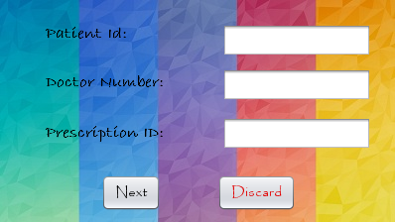

**private void jButton1ActionPerformed(java.awt.event.ActionEvent evt) {**

new HomePage().setVisible(true);

this.dispose();

**}**

**private void jButton2ActionPerformed(java.awt.event.ActionEvent evt) {**

Calendar c=Calendar.getInstance();

int cur_year=c.get(Calendar.YEAR);

int cur_month=c.get(Calendar.MONTH) +1;

int cur_day=c.get(Calendar.DAY_OF_MONTH);

String cm,cd;

if (cur_month<10) {

cm=""+0+cur_month; } else{ cm=""+cur_month; }

if(cur_day<10)

{ cd=""+0+cur_day; } else { cd=""+cur_day;}

String date=cur_year+cm+cd;

if(jTextField1.getText().isEmpty()||jTextField2.getText().isEmpty()||

jTextField3.getText().isEmpty())

{

if(jTextField1.getText().isEmpty()) {

jLabel1.setVisible(true);}

if(jTextField2.getText().isEmpty()) {

jLabel6.setVisible(true);}

if(jTextField3.getText().isEmpty()) {

jLabel7.setVisible(true);}

JOptionPane.showMessageDialog(this,"Please enter the indicated fields.");

}

else {

try {

jLabel1.setVisible(false); jLabel6.setVisible(false);

jLabel7.setVisible(false);

String patientid=(String)jTextField1.getText();

String pid=(String)jTextField2.getText();

String dno=(String)jTextField3.getText();

Class.forName("java.sql.DriverManager");

Connection con=(Connection)DriverManager.getConnection("jdbc:mysql://localhost:3306/mrproject","root","");

Statement s =(Statement) con.createStatement();

String qcc=jTextField3.getText();

String qc="SELECT * FROM invoice WHERE pid='"+qcc+"';";

ResultSet rsc=s.executeQuery(qc);

if(rsc.next())

{

JOptionPane.showMessageDialog(this,"Bill has already being generated....");

jTextField1.setText("");

jTextField2.setText("");

jTextField3.setText("");

}

else

{String qpp=jTextField1.getText();

String qp="SELECT MAX(pno) FROM patient;";

ResultSet rsp=s.executeQuery(qp);

if(rsp.next())

{

String rspp=rsp.getString("MAX(pno)");

if(Integer.parseInt(rspp)< Integer.parseInt(qpp))

{

JOptionPane.showMessageDialog(this,"Please enter proper Patient Id..");

jTextField1.setText("");

}

else

{

String a=jTextField3.getText();

String pr="SELECT pno FROM prescription WHERE pid='"+a+"';";

ResultSet rsq=s.executeQuery(pr);

if(rsq.next())

{

int pnnm= Integer.parseInt(rsq.getString("pno"));

if(Integer.parseInt(jTextField1.getText())==pnnm)

{

String q5="INSERT INTO invoice (pid,pno,dno,bill_date,amount,modepay) VALUES(NULL,NULL,NULL,NULL,NULL,NULL);";

s.executeUpdate(q5);

String q1="SELECT MAX(inno) FROM invoice;";

ResultSet rs=s.executeQuery(q1);

String i;

if(rs.next())

{

i=rs.getString("MAX(inno)");

String q="UPDATE invoice SET pid='"+dno+"',pno='"+patientid+"',dno='"+pid+"',bill_date='"+date+"' WHERE inno='"+i+"';";

s.executeUpdate(q);

jTextField1.setText("");

jTextField2.setText("");

jTextField3.setText("");

new New_Bill2(pid,dno).setVisible(true);

this.dispose();

}

else

{

JOptionPane.showMessageDialog(this,"No record found...");

}

}

else

{

JOptionPane.showMessageDialog(this,"Please enter correct prescription ID.");

jTextField3.setText("");

jLabel7.setVisible(true);

}

}

}

}

}

}

catch(Exception e)

{ JOptionPane.showMessageDialog(this, e.getMessage()); }

}

**}**

**private void jTextField1KeyTyped(java.awt.event.KeyEvent evt) {**

char kc=evt.getKeyChar();

if(!((kc>='0'&&kc<='9')||(kc==KeyEvent.VK_BACK_SPACE)||(kc==KeyEvent.VK_DELETE)))

{

JOptionPane.showMessageDialog(this, "Please enter the correct patient ID.");

evt.consume();

}

**}**

**private void jTextField2KeyTyped(java.awt.event.KeyEvent evt) {**

char kc=evt.getKeyChar();

if(!((kc>='0'&&kc<='9')||(kc==KeyEvent.VK_BACK_SPACE)||(kc==KeyEvent.VK_DELETE)))

{

JOptionPane.showMessageDialog(this, "Please enter the correct doctor ID.");

evt.consume();

}

**}**

**private void jTextField3KeyTyped(java.awt.event.KeyEvent evt) {**

char kc=evt.getKeyChar();

if(!((kc>='0'&&kc<='9')||(kc==KeyEvent.VK_BACK_SPACE)||(kc==KeyEvent.VK_DELETE)))

{

JOptionPane.showMessageDialog(this, "Please enter the correct prescription ID.");

evt.consume();

}

**}**

**private void formWindowOpened(java.awt.event.WindowEvent evt) {**

this.setBackground(new Color(0,0,0,0));

jLabel1.setVisible(false);

jLabel6.setVisible(false);

jLabel7.setVisible(false);

**}**

New Bill 2

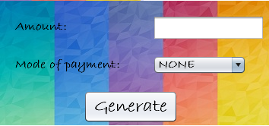

**private void jButton1ActionPerformed(java.awt.event.ActionEvent evt) {**

DefaultComboBoxModel model=(DefaultComboBoxModel)jComboBox1.getModel();

if(jComboBox1.getSelectedIndex()==0) {

jLabel5.setVisible(true);

JOptionPane.showMessageDialog(this,"Please enter the indicated fields.");}

else {

try {

jLabel5.setVisible(false);

String mode=(String)model.getSelectedItem();

Class.forName("java.sql.DriverManager");

Connection con=(Connection)DriverManager.getConnection("jdbc:mysql://localhost:3306/mrproject","root","");

Statement s =(Statement) con.createStatement();

String q1="SELECT MAX(inno) FROM invoice;";

ResultSet rs=s.executeQuery(q1);

String i;

if(rs.next())

{

String amount=jTextField4.getText();

i=rs.getString("MAX(inno)");

String q="UPDATE invoice SET amount='"+amount+"', modepay='"+mode+"' WHERE inno='"+i+"';";

s.executeUpdate(q);

JOptionPane.showMessageDialog(this,"Insertion sucessful..."+"\n The Invoice ID is "+i);

jTextField4.setText("");

jComboBox1.setSelectedIndex(0);

}

new New_Bill3().setVisible(true);

this.dispose();

} catch(Exception e) {

JOptionPane.showMessageDialog(this, e.getMessage());

}

}

**}**

**private void formWindowOpened(java.awt.event.WindowEvent evt) {**

this.setBackground(new Color(0,0,0,0));

jLabel5.setVisible(false);

try{

Class.forName("java.sql.DriverManager");

Connection con=(Connection)DriverManager.getConnection("jdbc:mysql://localhost:3306/mrproject","root","");

Statement s =(Statement) con.createStatement();

String q2="SELECT charge FROM doctor WHERE dno='"+pid1+"';";

ResultSet rs3=s.executeQuery(q2);

if(rs3.next())

{

String a1= rs3.getString("charge");

String q3="SELECT cost FROM prescription WHERE pid='"+dno1+"';";

ResultSet rs4=s.executeQuery(q3);

if(rs4.next())

{

String a2= rs4.getString("cost");

int a3= Integer.parseInt(a1)+ Integer.parseInt(a2);

jTextField4.setText(a3+"");

}

}

}

catch(Exception ea)

{

JOptionPane.showMessageDialog(this, ea);

}

**}**

New Bill 3

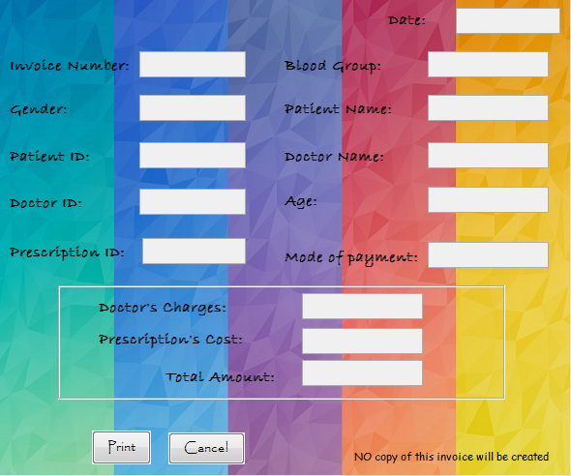

**private void formWindowOpened(java.awt.event.WindowEvent evt) {**

this.setBackground(new Color(0,0,0,0));

try{

Class.forName("java.sql.DriverManager");

Connection con=(Connection)DriverManager.getConnection("jdbc:mysql://localhost:3306/mrproject","root","");

Statement s =(Statement) con.createStatement();

String q1="SELECT MAX(inno) FROM invoice;";

ResultSet rs=s.executeQuery(q1);

String i;

if(rs.next())

{

//invoice

i=rs.getString("MAX(inno)");

String q="SELECT * FROM invoice WHERE inno='"+i+"';";

ResultSet rs1=s.executeQuery(q);

if(rs1.next())

{

jTextField9.setText(rs1.getString("bill_date"));

jTextField1.setText(i);

String d=rs1.getString("dno");

String p1=rs1.getString("pid");

jTextField10.setText(rs1.getString("pid"));

jTextField2.setText(rs1.getString("pno"));

jTextField7.setText(rs1.getString("modepay"));

//patient

String p=rs1.getString("pno");

String q2="SELECT * FROM patient WHERE pno='"+p+"';";

ResultSet rs2=s.executeQuery(q2);

if(rs2.next())

{

jTextField11.setText(rs2.getString("gender"));

jTextField8.setText(rs2.getString("age"));

jTextField12.setText(rs2.getString("b_gp"));

jTextField3.setText(rs2.getString("p_name"));

// doctor

String q3="SELECT * FROM doctor WHERE dno='"+d+"';";

ResultSet rs3=s.executeQuery(q3);

if(rs3.next())

{String charge=rs3.getString("charge");

jTextField4.setText(d);

jTextField5.setText(rs3.getString("d_name"));

String q4="SELECT cost FROM prescription WHERE pid='"+p1+"';";

ResultSet rs4=s.executeQuery(q4);

if(rs4.next())

{

String cost= rs4.getString("cost");

jTextField14.setText(charge);

jTextField13.setText(cost);

int fd=Integer.parseInt(charge)+ Integer.parseInt(cost);

jTextField6.setText(Integer.toString(fd));

} } } } }

}

catch(Exception e)

{

JOptionPane.showMessageDialog(this,e.getMessage());

}

**}**

**private void jButton1ActionPerformed(java.awt.event.ActionEvent evt) {**

JOptionPane.showMessageDialog(this,"The invoice has been printed....");

clear();

new HomePage().setVisible(true);

**}**

**private void jButton2ActionPerformed(java.awt.event.ActionEvent evt) {**

int confirm=JOptionPane.showConfirmDialog(this,"Do you want to cancel it ???","Confirm",JOptionPane.YES_NO_OPTION);

if(confirm==0)

{

try{

Class.forName("java.sql.DriverManager");

Connection con=(Connection)DriverManager.getConnection("jdbc:mysql://localhost:3306/mrproject","root","");

Statement s =(Statement) con.createStatement();

String qw=jTextField1.getText();

String q="DELETE FROM invoice WHERE inno='"+qw+"';";

JOptionPane.showMessageDialog(this,"Invoice deleted....");

this.dispose();

new HomePage().setVisible(true);

}

catch(Exception e)

{

JOptionPane.showMessageDialog(this,e.getMessage());

}

}

**}**

Doctor Update

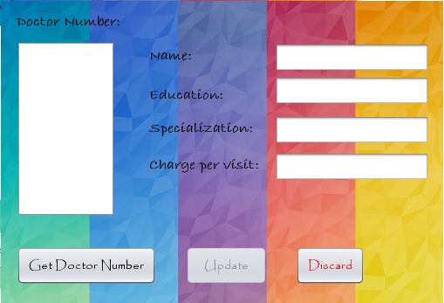

**private void jButton2ActionPerformed(java.awt.event.ActionEvent evt) {**

if (jTextField4.getText().isEmpty() || jTextField1.getText().isEmpty() || jTextField2.getText().isEmpty() || jTextField3.getText().isEmpty()) {

jButton2.setEnabled(true);

JOptionPane.showMessageDialog(this, "Please enter the values in the empty spaces.");

} else if (Integer.parseInt(jTextField3.getText()) > 1800) {

JOptionPane.showMessageDialog(this, "Please enter economical charges per visit.");

jTextField3.setText("");

} else if (Integer.parseInt(jTextField3.getText()) < 300) {

JOptionPane.showMessageDialog(this, "Please enter correct charges per visit.");

jTextField3.setText("");

} else {

int confirm = JOptionPane.showConfirmDialog(this, "Do you want to update the data?", "Confirm", JOptionPane.YES_NO_OPTION);

if (confirm == 0) {

try {

String d_name = jTextField4.getText();

String edu = jTextField1.getText();

String spe = jTextField2.getText();

String charge = jTextField3.getText();

String dno = (String) jList1.getSelectedValue();

Class.forName("java.sql.DriverManager");

Connection con = (Connection) DriverManager.getConnection("jdbc:mysql://localhost:3306/mrproject", "root", "");

Statement s = (Statement) con.createStatement();

if (!(jTextField4.getText().isEmpty())) {

String q1 = "UPDATE doctor SET d_name='" + d_name + "' WHERE dno='" + dno + "';";

s.executeUpdate(q1);

}

if (!(jTextField1.getText().isEmpty())) {

String q1 = "UPDATE doctor SET edu='" + edu + "' WHERE dno='" + dno + "';";

s.executeUpdate(q1);

}

if (!(jTextField2.getText().isEmpty())) {

String q1 = "UPDATE doctor SET specialization='" + spe + "' WHERE dno='" + dno + "';";

s.executeUpdate(q1);

}

if (!(jTextField3.getText().isEmpty())) {

String q1 = "UPDATE doctor SET charge='" + charge + "' WHERE dno='" + dno + "';";

s.executeUpdate(q1);

}

JOptionPane.showMessageDialog(this, "Data update Successful...");

jTextField1.setEditable(false);

jTextField2.setEditable(false);

jTextField4.setEditable(false);

jTextField3.setEditable(false);

jTextField3.setText("");

jTextField1.setText("");

jTextField2.setText("");

jTextField4.setText("");

jButton2.setEnabled(false);

} catch (Exception e) {

JOptionPane.showMessageDialog(this, e.getMessage());

}

} else {

}

}

**}**

**private void jTextField3KeyTyped(java.awt.event.KeyEvent evt) {**

char kc = evt.getKeyChar();

if (!((kc >= '0' && kc <= '9') || (kc == KeyEvent.VK_BACK_SPACE) || (kc == KeyEvent.VK_DELETE))) {

JOptionPane.showMessageDialog(this, "Please enter the correct charges to be taken per visit.");

evt.consume();

}

**}**

**private void jTextField1KeyTyped(java.awt.event.KeyEvent evt) {**

char kc = evt.getKeyChar();

if (!((kc >= 'a' && kc <= 'z') || (kc == KeyEvent.VK_BACK_SPACE) || (kc == KeyEvent.VK_DELETE) || (kc >= 'A' && kc <= 'Z') || (kc == '.'))) {

JOptionPane.showMessageDialog(this, "Please enter the correct education");

evt.consume();

}

**}**

**private void jButton4ActionPerformed(java.awt.event.ActionEvent evt) {**

new HomePage().setVisible(true);

this.dispose();

**}**

**private void jTextField2KeyTyped(java.awt.event.KeyEvent evt) {**

char kc = evt.getKeyChar();

if (!((kc >= 'a' && kc <= 'z') || (kc == KeyEvent.VK_BACK_SPACE) || (kc == KeyEvent.VK_DELETE))) {

JOptionPane.showMessageDialog(this, "Please enter the correct specialization.");

evt.consume();

}

**}**

**private void jButton1ActionPerformed(java.awt.event.ActionEvent evt) {**

DefaultListModel list = (DefaultListModel) jList1.getModel();

try {

Class.forName("java.sql.DriverManager");

Connection con = (Connection) DriverManager.getConnection("jdbc:mysql://localhost:3306/mrproject", "root", "");

Statement s = (Statement) con.createStatement();

String q = "SELECT dno FROM doctor ;";

ResultSet rs = s.executeQuery(q);

if (rs.next()) {

rs.previous();

while (rs.next()) {

String dno = rs.getString("dno");

list.addElement(dno);

}

} else {

JOptionPane.showMessageDialog(this, "No record found...");

}

} catch (Exception ea) {

JOptionPane.showMessageDialog(this, ea.getMessage());

}

jList1.setSelectedIndex(0);

jButton1.setEnabled(false);

**}**

**private void jTextField4KeyTyped(java.awt.event.KeyEvent evt) {**

char kc = evt.getKeyChar();

if (!((kc >= 'a' && kc <= 'z') || (kc == KeyEvent.VK_BACK_SPACE) || (kc == KeyEvent.VK_DELETE) || (kc == '.'))) {

JOptionPane.showMessageDialog(this, "Please enter correct the name.");

evt.consume();

}

**}**

**private void jList1MousePressed(java.awt.event.MouseEvent evt) {**

if (jList1.getSelectedIndex() < 0) {

JOptionPane.showMessageDialog(this, "Please select a doctor number.");

} else {

jButton2.setEnabled(true);

try {

jButton2.setEnabled(true);

jTextField1.setEditable(true);

jTextField2.setEditable(true);

jTextField4.setEditable(true);

jTextField3.setEditable(true);

Class.forName("java.sql.DriverManager");

Connection con = (Connection) DriverManager.getConnection("jdbc:mysql://localhost:3306/mrproject", "root", "");

Statement s = (Statement) con.createStatement();

String dno = (String) jList1.getSelectedValue();

String q1 = "SELECT d_name,edu,specialization,charge FROM doctor WHERE dno='" + dno + "';";

ResultSet rs = s.executeQuery(q1);

if (rs.next()) {

jTextField1.setText(rs.getString("edu"));

jTextField4.setText(rs.getString("d_name"));

jTextField2.setText(rs.getString("specialization"));

jTextField3.setText(rs.getString("charge"));

}

} catch (Exception ae) {

JOptionPane.showMessageDialog(this, ae.getMessage());

}

}

**}**

**private void formWindowOpened(java.awt.event.WindowEvent evt) {**

this.setBackground(new Color(0, 0, 0, 0));

**}**

Doctor Delete

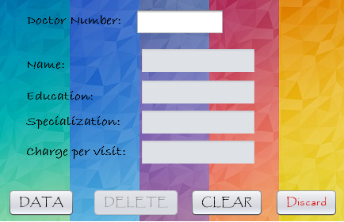

**private void jButton2ActionPerformed(java.awt.event.ActionEvent evt) {**

int confirm = JOptionPane.showConfirmDialog(this, "Do you want to delete it???", "Confirm", JOptionPane.YES_NO_OPTION);

if (confirm == 0) {

String dno = jTextField1.getText();

try {

Class.forName("java.sql.DriverManager");

Connection con = (Connection) DriverManager.getConnection("jdbc:mysql://localhost:3306/mrproject", "root", "");

Statement s = (Statement) con.createStatement();

String q = "DELETE FROM doctor WHERE dno='" + dno + "';";

s.executeUpdate(q);

JOptionPane.showMessageDialog(this, "Record deleted.");

jTextField1.setText("");

jTextField2.setText("");

jTextField3.setText("");

jTextField4.setText("");

jTextField5.setText("");

} catch (Exception e) {

JOptionPane.showMessageDialog(this, e.getMessage());

}

} else {

}

jButton2.setEnabled(false);

jButton1.setEnabled(true);

**}**

**private void jTextField1KeyTyped(java.awt.event.KeyEvent evt) {**

char kc = evt.getKeyChar();

if (!((kc >= '0' && kc <= '9') || (kc == KeyEvent.VK_BACK_SPACE) || (kc == KeyEvent.VK_DELETE))) {

JOptionPane.showMessageDialog(this, "Please enter the correct mobile number.");

evt.consume();

}

**}**

**private void jButton3ActionPerformed(java.awt.event.ActionEvent evt) {**

jTextField1.setText("");

jTextField2.setText("");

jTextField3.setText("");

jTextField4.setText("");

jButton2.setEnabled(false);

jButton1.setEnabled(true);

jTextField5.setText("");

**}**

**private void jButton4ActionPerformed(java.awt.event.ActionEvent evt) {**

HomePage home = new HomePage();

home.setVisible(true);

this.dispose();

**}**

**private void jButton1ActionPerformed(java.awt.event.ActionEvent evt) {**

if (jTextField1.getText().isEmpty()) {

JOptionPane.showMessageDialog(this, "Please enter the Doctor Number.");

} else {

try {

String dno = (String) jTextField1.getText();

Class.forName("java.sql.DriverManager");

Connection con = (Connection) DriverManager.getConnection("jdbc:mysql://localhost:3306/mrproject", "root", "");

Statement s = (Statement) con.createStatement();

String q = "SELECT d_name,edu,specialization,charge FROM doctor WHERE dno='" + dno + "';";

ResultSet rs = s.executeQuery(q);

if (rs.next()) {

jTextField2.setText(rs.getString("d_name"));

jTextField3.setText(rs.getString("edu"));

jTextField4.setText(rs.getString("specialization"));

jTextField5.setText(rs.getString("charge"));

jButton2.setEnabled(true);

jButton1.setEnabled(false);

} else {

jButton1.setEnabled(true);

JOptionPane.showMessageDialog(this, "No record found.");

jTextField1.setText("");

}

} catch (Exception e) {

JOptionPane.showMessageDialog(this, e.getMessage());

}

}

**}**

**private void formWindowOpened(java.awt.event.WindowEvent evt) {**

this.setBackground(new Color(0, 0, 0, 0));

**}**

About Us

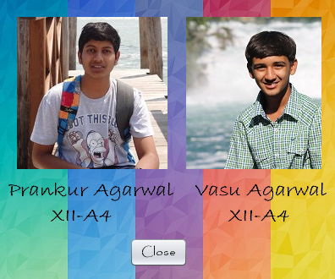

**private void formWindowOpened(java.awt.event.WindowEvent evt) {**

this.setBackground(new Color(0,0,0,0));

**}**

**private void jButton1ActionPerformed(java.awt.event.ActionEvent evt) {**

new HomePage().setVisible(true);

this.dispose();

**}**

Report

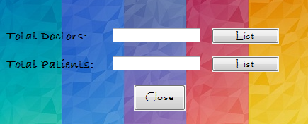

**private void formWindowOpened(java.awt.event.WindowEvent evt) {**

this.setBackground(new Color(0, 0, 0, 0));

try{

Class.forName("java.sql.DriverManager");

Connection con = (Connection)DriverManager.getConnection("jdbc:mysql://localhost:3306/mrproject","root","");

Statement stmt = (Statement)con.createStatement();

String query1 = "Select count(*) from doctor;";

String query2 = "Select count(*) from patient;";

ResultSet rs1 = (ResultSet)stmt.executeQuery(query1);

while(rs1.next()){

jTextField1.setText(rs1.getString("count(*)"));

}

ResultSet rs2 = (ResultSet)stmt.executeQuery(query2);

while(rs2.next()){

jTextField2.setText(rs2.getString("count(*)"));

} }

catch(Exception e){

JOptionPane.showMessageDialog(this, e.getMessage());

}

jTextField1.setEnabled(false);

jTextField2.setEnabled(false);

int i = Integer.parseInt(jTextField1.getText());

int j = Integer.parseInt(jTextField2.getText());

if(i==0){

jButton1.setEnabled(false);

JOptionPane.showMessageDialog(this, "No doctors!");

}

if(j==0){

jButton2.setEnabled(false);

JOptionPane.showMessageDialog(this, "No patients!");

}

**}**

**private void jButton3ActionPerformed(java.awt.event.ActionEvent evt) {**

new HomePage().setVisible(true);

this.dispose();

**}**

**private void jButton1ActionPerformed(java.awt.event.ActionEvent evt) {**

new Doctor_List().setVisible(true);

this.dispose();

**}**

**private void jButton2ActionPerformed(java.awt.event.ActionEvent evt) {**

new Patient_List().setVisible(true);

this.dispose();

**}**

Patient List

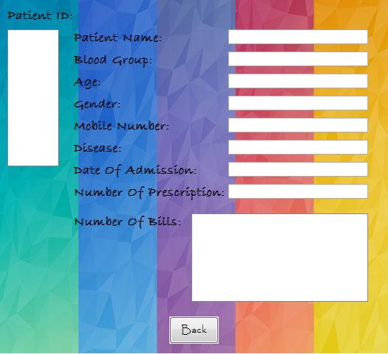

**private void jList1MouseClicked(java.awt.event.MouseEvent evt) {**

try {

Class.forName("java.sql.DriverManager");

Connection con=(Connection)DriverManager.getConnection("jdbc:mysql://localhost/mrproject","root","");

Statement stmt=(Statement)con.createStatement();

String pno= (String)jList1.getSelectedValue();

String query1="Select * from patient where pno='"+(pno)+"';";

String query2="Select count(*) from prescription where pno='"+(pno)+"';";

String query4="Select count(*) from invoice where pno='"+(pno)+"';";

ResultSet rs1=stmt.executeQuery(query1);

while (rs1.next()) {

jTextField1.setText(rs1.getString("p_name"));

jTextField2.setText(rs1.getString("b_gp"));

jTextField3.setText(rs1.getString("age"));

jTextField4.setText(rs1.getString("gender"));

jTextField5.setText(rs1.getString("mobileno"));

jTextField6.setText(rs1.getString("disease"));

jTextField7.setText(rs1.getString("entry_date"));

}

ResultSet rs2=stmt.executeQuery(query2);

while (rs2.next()) {

jTextField8.setText(rs2.getString("count(*)"));

}

int p = Integer.parseInt(jTextField8.getText());

ResultSet rs4=stmt.executeQuery(query4);

while (rs4.next()) {

jTextArea1.setText(rs4.getString("count(*)"));

}

int b = Integer.parseInt(jTextArea1.getText());

if(b==p){

jTextArea1.append("\n" +"All bills paid!");

}else{

int d = p-b;

jTextArea1.append("\n" +"Bills Paid:" + b + "\n" + "Bills Unpaid: " + d);

}

}

catch (Exception e) {

JOptionPane.showMessageDialog(this, e.getMessage());

}

**}**

**private void formWindowOpened(java.awt.event.WindowEvent evt) {**

this.setBackground( new Color(0,0,0,0));

DefaultListModel d1 = (DefaultListModel)jList1.getModel();

try{

Class.forName("java.sql.DriverManager");

Connection con = (Connection)DriverManager.getConnection("jdbc:mysql://localhost:3306/mrproject","root","");

Statement stmt = (Statement)con.createStatement();

String query = "Select pno from patient;";

ResultSet rs = (ResultSet)stmt.executeQuery(query);

while(rs.next()){

d1.addElement(rs.getString("pno"));

}

}

catch(Exception e){

JOptionPane.showMessageDialog(this, e.getMessage());

}

jTextField1.setEnabled(false);

jTextField2.setEnabled(false);

jTextField3.setEnabled(false);

jTextField4.setEnabled(false);

jTextField5.setEnabled(false);

jTextField6.setEnabled(false);

jTextField7.setEnabled(false);

jTextField8.setEnabled(false);

jTextArea1.setEnabled(false);

**}**

**private void jButton4ActionPerformed(java.awt.event.ActionEvent evt) {**

new Report().setVisible(true);

this.dispose();

**}**

Doctor List

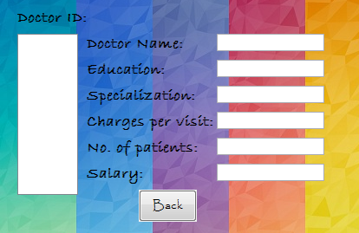

**private void formWindowOpened(java.awt.event.WindowEvent evt) {**

this.setBackground( new Color(0,0,0,0));

DefaultListModel d1 = (DefaultListModel)jList1.getModel();

try{

Class.forName("java.sql.DriverManager");

Connection con = (Connection)DriverManager.getConnection("jdbc:mysql://localhost:3306/mrproject","root","");

Statement stmt = (Statement)con.createStatement();

String query = "Select dno from doctor;";

ResultSet rs = (ResultSet)stmt.executeQuery(query);

while(rs.next()){

d1.addElement(rs.getString("dno"));

}

}

catch(Exception e){

JOptionPane.showMessageDialog(this, e.getMessage());

}

jTextField1.setEnabled(false);

jTextField2.setEnabled(false);

jTextField3.setEnabled(false);

jTextField4.setEnabled(false);

jTextField5.setEnabled(false);

jTextField6.setEnabled(false);

**}**

**private void jList1MouseClicked(java.awt.event.MouseEvent evt) {**

try {

Class.forName("java.sql.DriverManager");

Connection con=(Connection)DriverManager.getConnection("jdbc:mysql://localhost/mrproject","root","");

Statement stmt=(Statement)con.createStatement();

String dno= (String)jList1.getSelectedValue();

String query1="Select * from doctor where dno='"+(dno)+"';";

String query2="Select count(*) from prescription where dno='"+(dno)+"';";

ResultSet rs1=stmt.executeQuery(query1);

while (rs1.next()) {

jTextField1.setText(rs1.getString("d_name"));

jTextField2.setText(rs1.getString("edu"));

jTextField3.setText(rs1.getString("specialization"));

jTextField4.setText(rs1.getString("Charge"));

}

ResultSet rs2=stmt.executeQuery(query2);

while (rs2.next()) {

jTextField5.setText(rs2.getString("count(*)"));

}

}

catch (Exception e) {

JOptionPane.showMessageDialog(this, e.getMessage());

}

int ch = Integer.parseInt(jTextField4.getText());

int pn = Integer.parseInt(jTextField5.getText());

int sal1 = pn * ch;

int sal2 = pn * 200;

int sal = sal1 + sal2;

jTextField6.setText(String.valueOf(sal));

**}**

**private void jButton4ActionPerformed(java.awt.event.ActionEvent evt) {**

new Report().setVisible(true);

this.dispose();

**}**

**Bibliography**

* NCERT Text Book
* Sumita Arora
* www.google.com
* www.java2s.com